# Manual testing-

**Syllabus-**

**Manual Part 1 – (Tester 1) (web application)**

1. **Basic software testing** – QA/ QC, Peoples, Company, Testing, project, etc
2. **Different types of Process** – SDLC, Waterfall module, V-module, **Agile process**, etc
3. **Different types testing –** Sanity Testing, Smoke Testing, BBT/ System & functional testing, Re-testing, regression testing, UAT, Production Testing, etc

**Manual Part 2 – Real tester work**

1. STLC, Test cases design, Test cases review, Test cases execution, Defect/Bug raise, Demo/ review of functionality, Different type of report, etc

**Database testing-**

1. **Database testing** – SQL languages, SQL server tool, etc

**API testing- (Tester 2)**

1. **API testing** – API testing – Postman tool used for API testing.

**API Testing** – manual testing –

**API Testing** – Automation testing / Rest-assured – **New**\*\*

**Project management tool/ Defect tracing tool –**

1. Project – track tool – JIRA, Azure DeVos, TFS, etc – TCD, defect/ bug lock

**Automation Testing- (web-based application) (Tester 3)**

1. Java languages – Basic to advance tester points.
2. Selenium tool – web basic application
3. Framework –

**2 project –**

1. Different domain – CRM domain, etc
2. Different domain – Fintech domain/ Insurance domain, etc

# Manual testing-

**Project -**

Client, USA (Web based Application – Danske bank) 🡪 Project implemented / requirement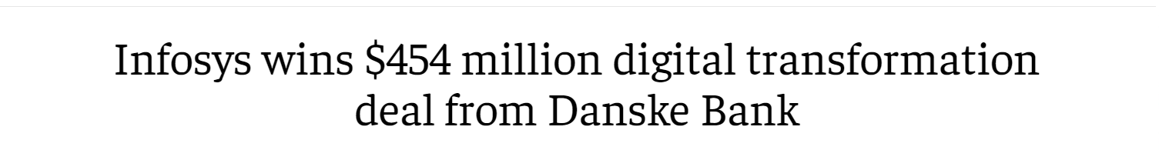

India (Infosys, Pune) – Serviced based company – TCS, Infosys, etc

India (Amdoc, PTC, Pune) – Produced based company – Billing Produced

**Development Testing**

(Frond end, Backend end, Database) (Manual testing, Automation Testing)

**Serviced based company -**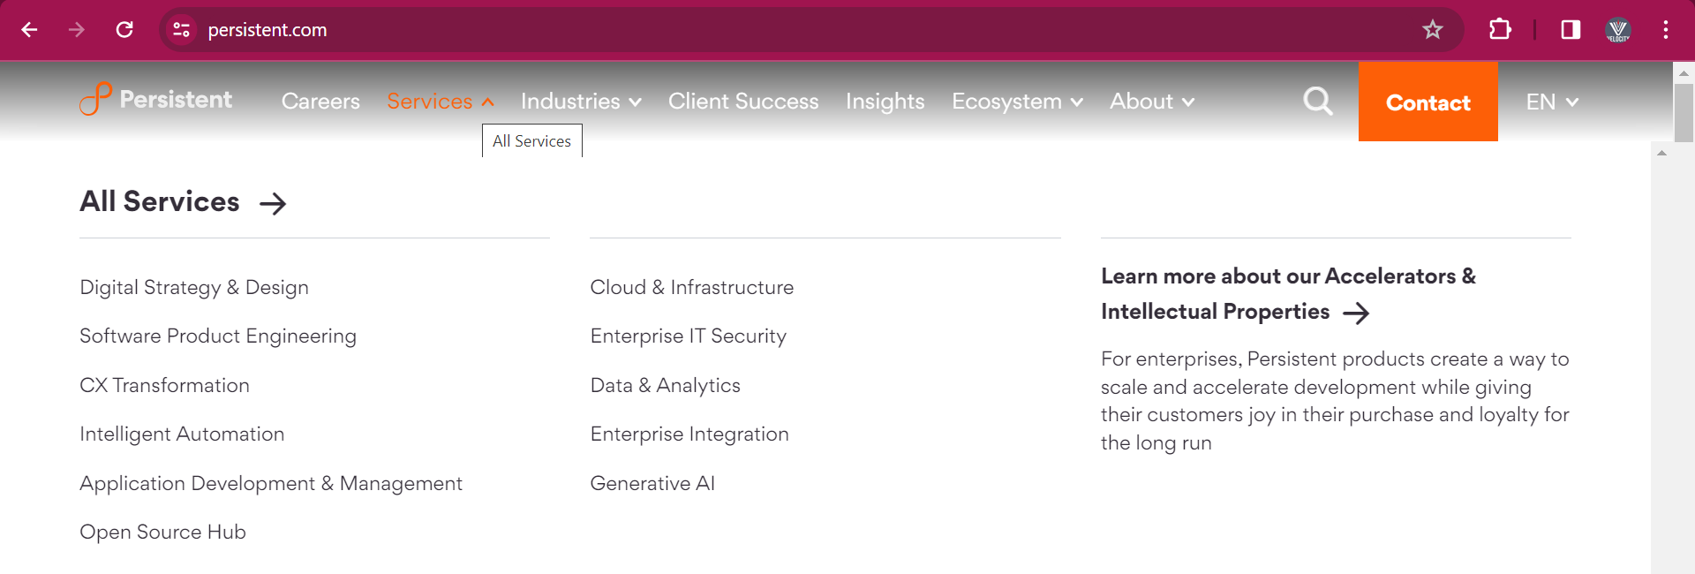

**Produced based company-**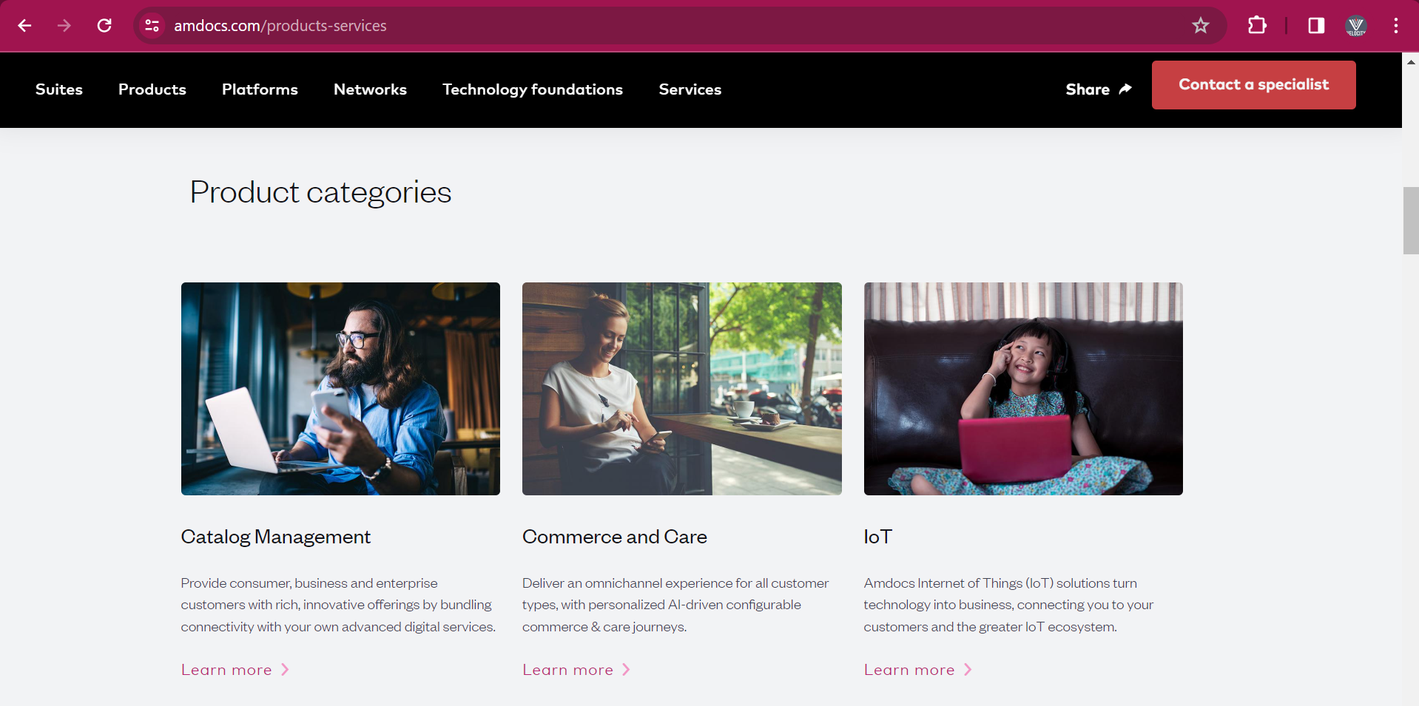

# Project work-

1. **Project development** - Newfunctionality/ New Module/ New feature addition in application.

**Ex**. Phone pay – Share market by phone pay.

**Ex**. Phone pay – Repay card linking phone pay.

1. **Project support** – Existing application issue/ bug, End user quires, Ticket, Change request, Enhancement, etc

**Ex**. Recharge, Money transfer mobile number – raised, Ticket, Call customer care – ID, etc

* Ex. Desake bank – project development & project support – Infosys company
* Ex. Softbank bank – project development - TCS company & project support – Infosys company
* Ex. HSBC bank (client) – project development – TCS, Infosys, Zensar, Cyient, Capgemini vendor company & project support – Infosys company

# Project Team size**-

**Project development -**

1. **Client** – Web based application need to development/ existing web application digital transformation.
2. **Product Specialist / Business Analyst/ Consultant (BA) (1)** – Requirement collection from client. These requirements will send to project team. Product Specialist / Business Analyst/ Consultant will work as **mediator between client and project team**.

**Project Team (16 peoples) -** Newfunctionality/ New Module/ New feature addition.

1. **Delivery manager (DM) (1)** – To care of deployment/ deliveryof development functionality/ module.
2. **Project manager (PM) (1) –** project related work/ task assign and daily basis work progress ask.
3. **Designer / Solution arch. / Development Lead (1)–** Project related work for Frond end, Backend end & Database need to designer/ solution.
4. **Developer (8) –** Developer will do thecoding against

*Frond end* - they will do coding against functionality/ Module/ new feature addition

*Backend/ API end* - they will do coding against functionality/ Module/ new feature addition

*Database* – they will do coding against functionality/ Module/ new feature addition.

1. **Testing Lead (1) –** testing related work – testing report generation, framework impalement, Testing related process/ documents, etc
2. **Tester (3) –** Testing/ checking these implements functionality/ Module/ new feature addition as per given requirement.

* **I have worked**, **in project team** with **team size of 16 peoples**.

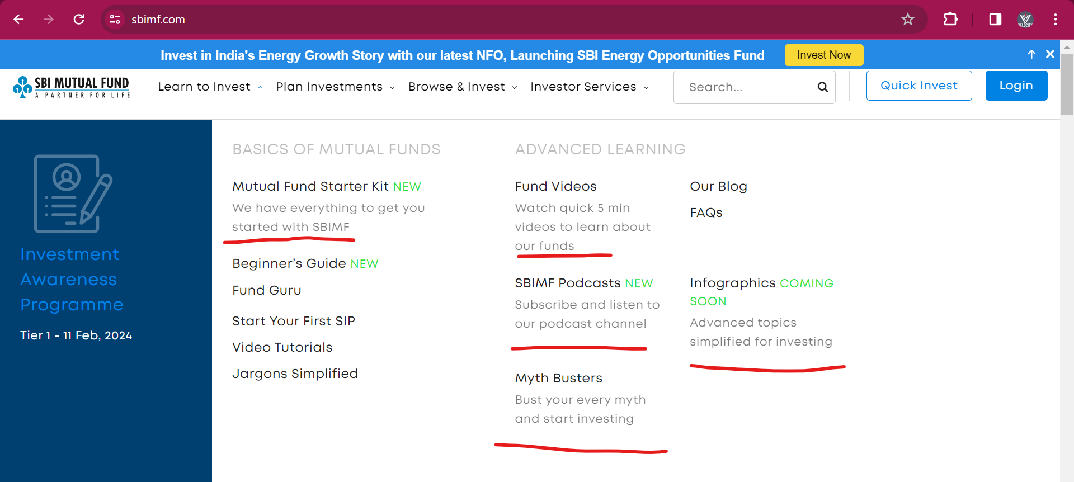

**Support Team (4 people) -** Existingapplication**/** functionality/ Module– Issue, Bug, New feature, Enhancement, User request/ quires, Ticket, etc

1. **Support/ Customer manager (1) –** Support project related Issue, feature, Enhancement, etc assign to developer and tester.
2. **Developer (2) –** Developer will do thecoding againstIssue, Bug, New feature, Enhancement.
3. **Tester (1) –** Testing these Issue, Bug, New feature, Enhancement which is development.

* Depending on project work, Project team size will be very.

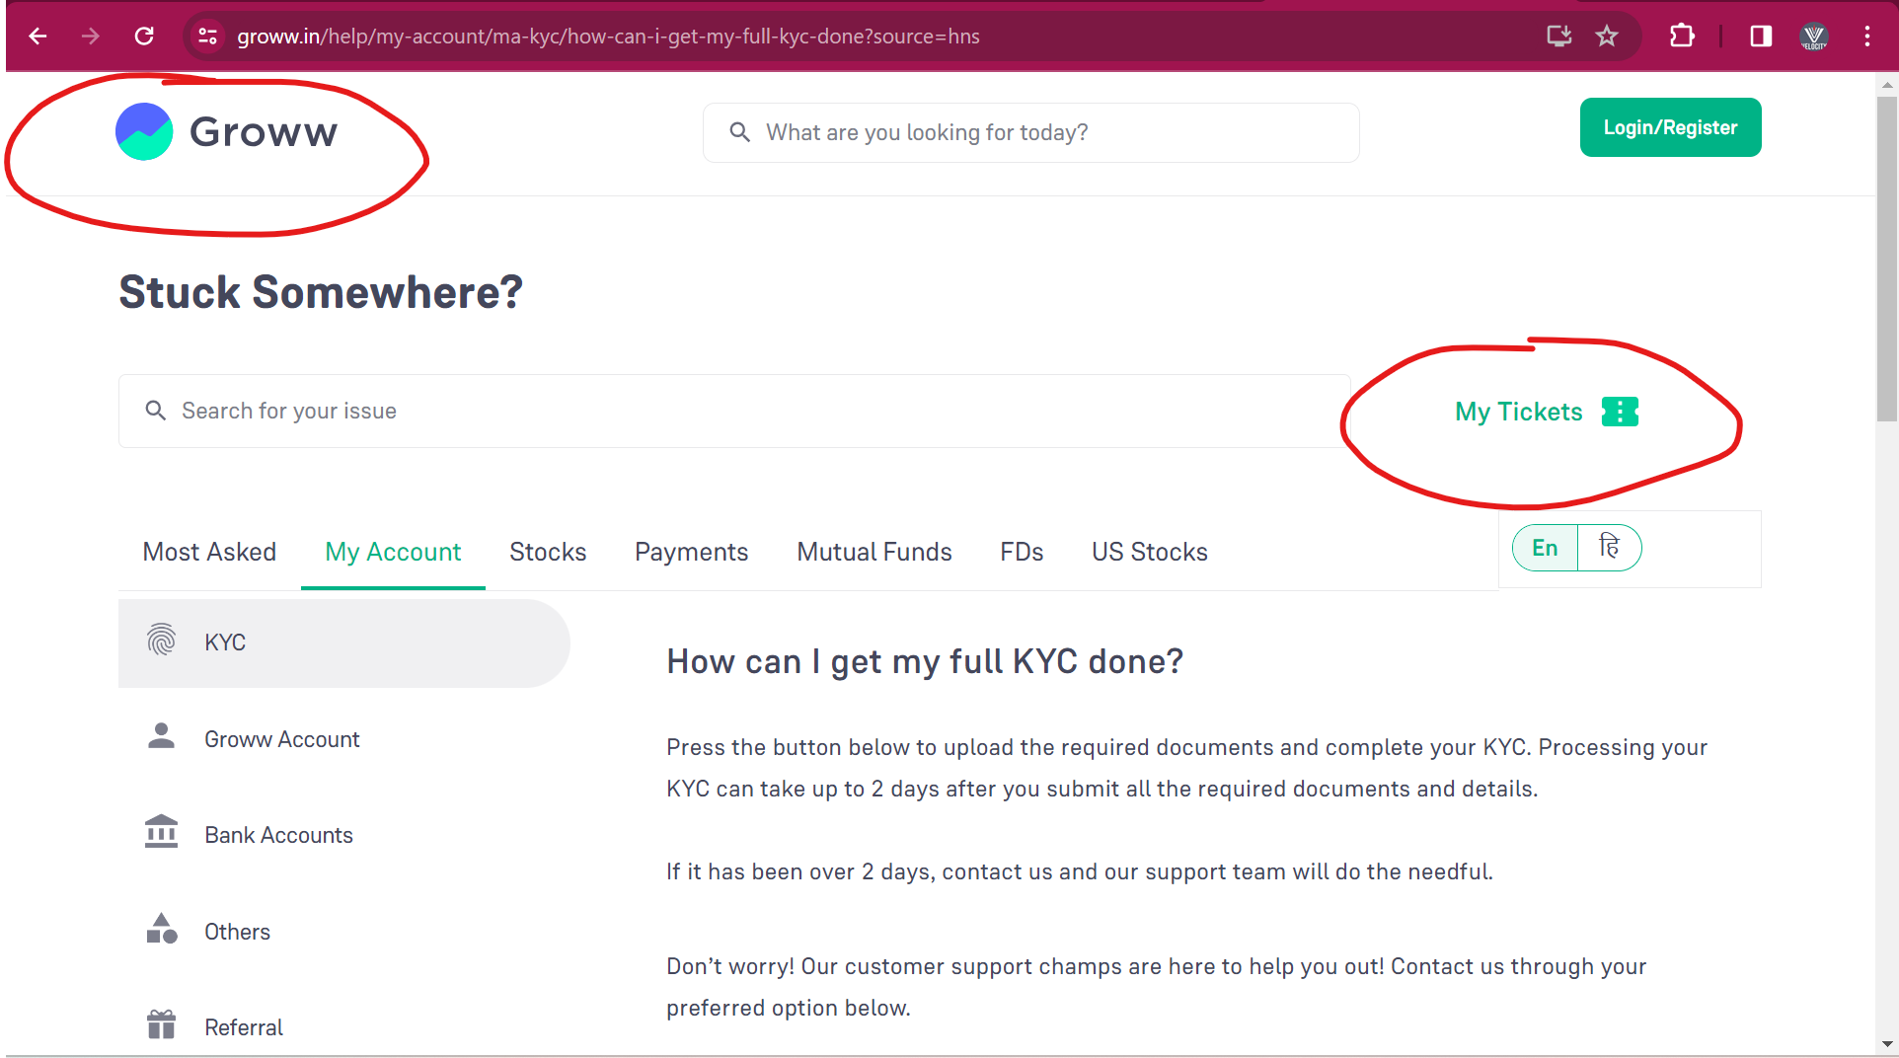

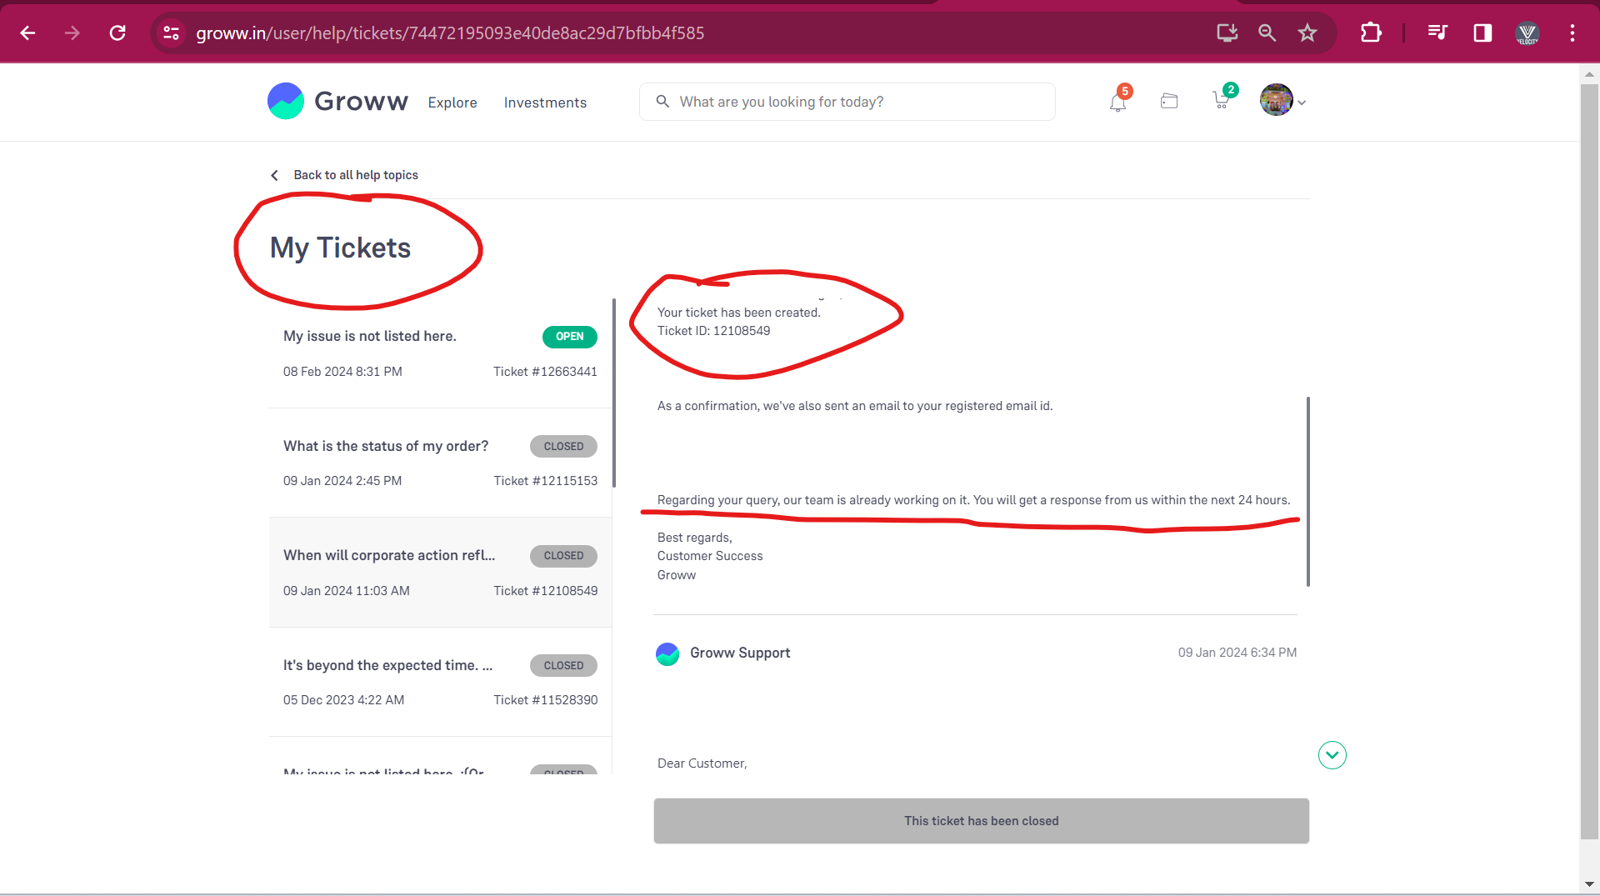

**Module-**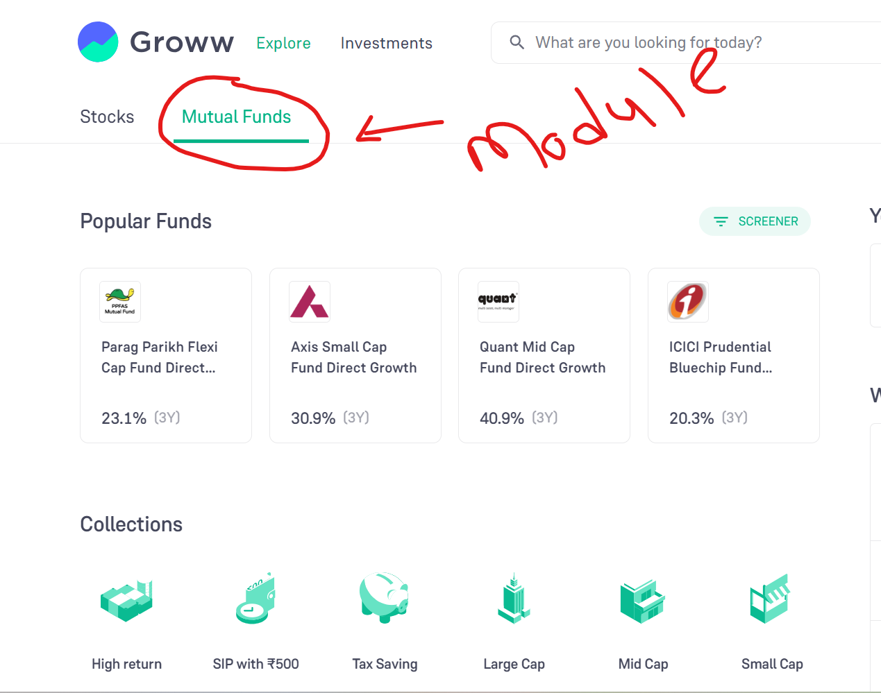

**Feature-**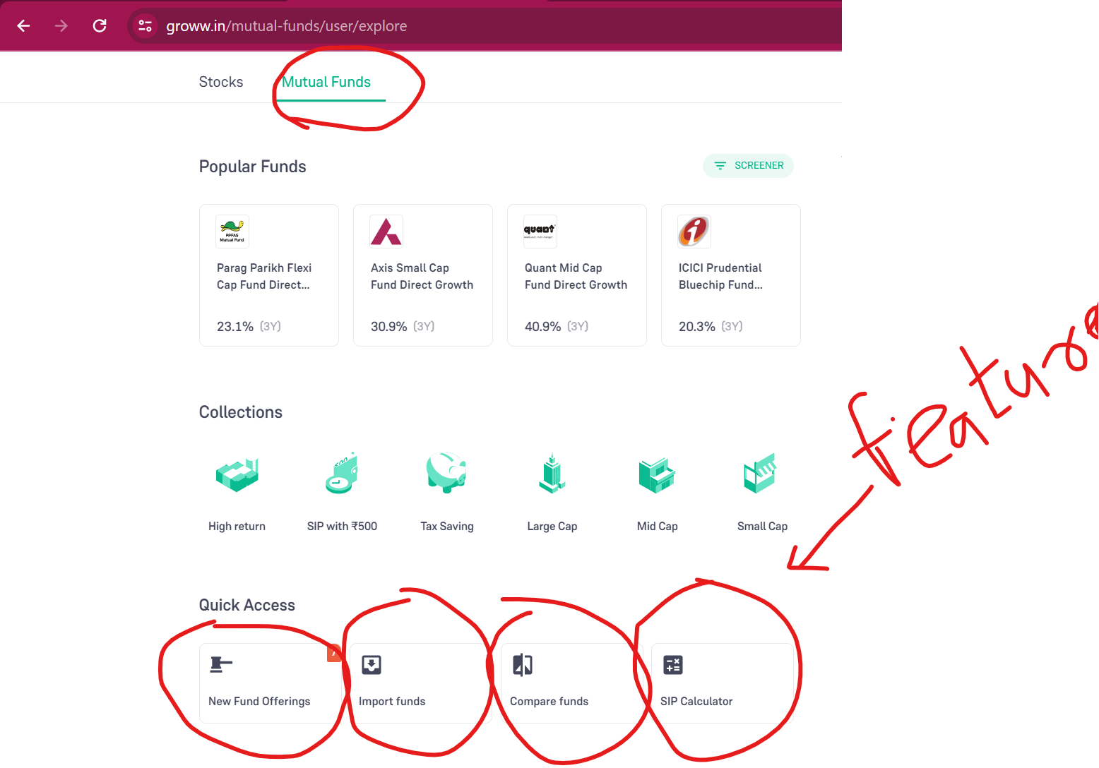

**Functionality-** 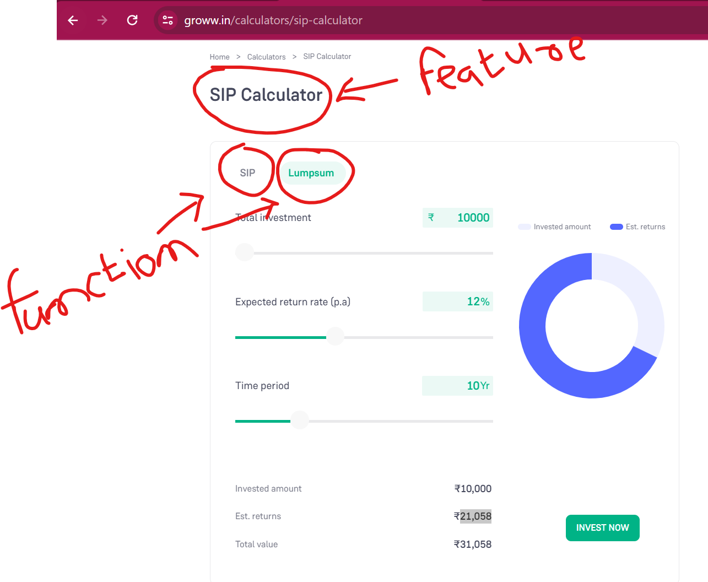

# Software –

* Software it is set of program/ collection of programs that helps to run the application.
* Types of software –

1. **System software** – OS, Driver- audio software, etc
2. **Application software** –
3. Web based application (ex. Paytm, IRCTC, https://hbl.in, vctcpune.com),
4. Mobile based application (ex. Paytm, Swiggy),
5. Desktop based (ex. PVR ticket online), etc

# Software Testing -

* To check/ verify the software application as per the requirement.

**Why software testing need-**

* To avoid bug/ issue in application
* To identify the bug/ error in application
* To gain customer confidence/ satisfy
* To increase the productivity/ quantity
* To check software adaptability/ suitability
* To avoid risk in the business.

# Different types of process follow in project-

* **Process –**
* Process will be decided by company or client will be decide.
* Process different types –

1. SDLC (software development life cycle)/ Basic process
2. Waterfall process
3. V-module process
4. **Agile Process – 90 to 95% in every project these processes follow.**

# SDLC (software development life cycle)**-

* SDLC called as software development life cycle
* SDLC will contains stage/ phase –

1. **Information gathering - BRS**
2. **Requirement analysis – SRS/ FRS/ CRS**
3. **Designing**
4. **Coding**
5. **Testing**
6. **Support/ maintenance**

**Information gathering-**

* In Information gathering stage, BA will work
* BA will collect all **requirement related to client business.**
* BA will make a document related to this client business requirement **and it is called as BRS** (business requirement specification).
* BRS will contains only client business ideas.
* Client business reequipment –
* **Ex**. Client – application/ platform – customer/end user bidding – Cricket, Football, Kabadi, etc – Client business will increase when customer/end user will be bidding on cricket. – Platform charge. (ex. Dram11 – end user 10*10rs = 100rs – winner prize = 90rs and 10rs will be charged as Platform charge)
* **Ex.** Client – application/ platform – customer/end user will be providing loan – Client business will increase when customer/end use will take load and repay with intersect rate.

**Requirement analysis –**

* In **Requirement analysis stage,** BA will work.
* BA will collect all **requirement related to application/ software/ system** from client.
* BA will make a document related to this application/ software/ system requirement **and it is called as SRS** (system requirement specification/ software requirement specification).
* SRS also called **FRS** (functional requirement specification)/ **CRS** (customer requirement specification)
* SRS will contain (Phonepay project - **Recharge module - SRS)**

1. **Functional requirement** (1 module = Recharge module = 10 requirement)
2. **Functional flow diagrams**
3. **Use cases / Single specific requirement**
4. **Description –** Details about the Use cases / Single specific requirement
5. **Acceptance criteria –** Does & Don’t about the Use cases / Single specific req.
6. **Screenshot / Protype/ Wireframe**

* **Ex.** Phonepay project – **Recharge module (SRS) –**

**Flow requirement –**

**Req1- Sing up,**

**Req2- Login page -** Existing customer – Login mobile no & Email ID, error message

**Req3- Home dashboard/ page – Recharge Icon,**

**Req4- Recharge Mobile details,**

**Req5- Plane related to operator & Circle,**

**Req6- Browser plane related to circle & operator,**

**Req7- Promo code,**

**Req8- Payment debt card/ credit card,**

**Req9- Thanks message, Emails/ SMS generation.**

* BA after confirmation from client then sent to project team.
* When these SRS will be complete then BA will send these SRS document to project team.
* Project team, will read/ understand these documents.
* If there is a problem or not understand some requirement, then project team will take one call/ meeting with BA.

**Designing-**

* In designer stage, **Designer / Solution arch. / Development Lead** will work.
* Designer will prepare a protype (HLD & LLD) for these requirement/ functionality (Frond end, Backend & Database)
* **HDL** – high level design (**Ex**. Functionality – Frond end mobile no. details page – Mobile no. – API call to take detail of these mobile no.- DB will store details)
* Designer will give this work to developer.

**Coding –**

* In coding stage, **developer** will work
* Developer will do coding against these LLD (low level design) interns of Frond end, API and database.
* In LLD – Frond end, API & DB related coding performed
* Ex. **Frond end** – Mobile no enter details page – 10 digits text box, operator plane select tab, Operator select drop down, Browse tab, Amount – text box (10rs to 9999rs)

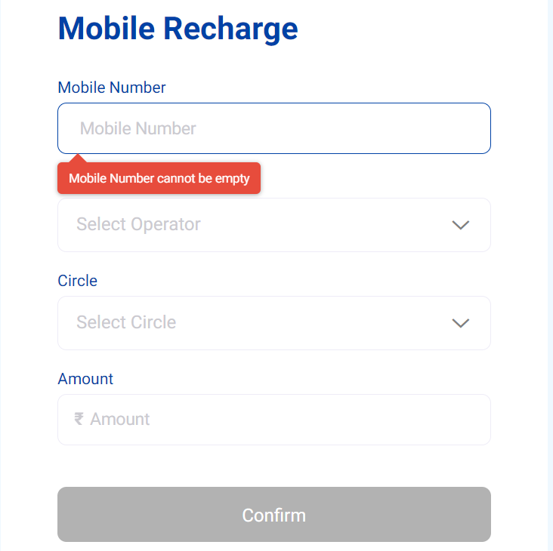

* **API coding** – GET call, POST call, etc

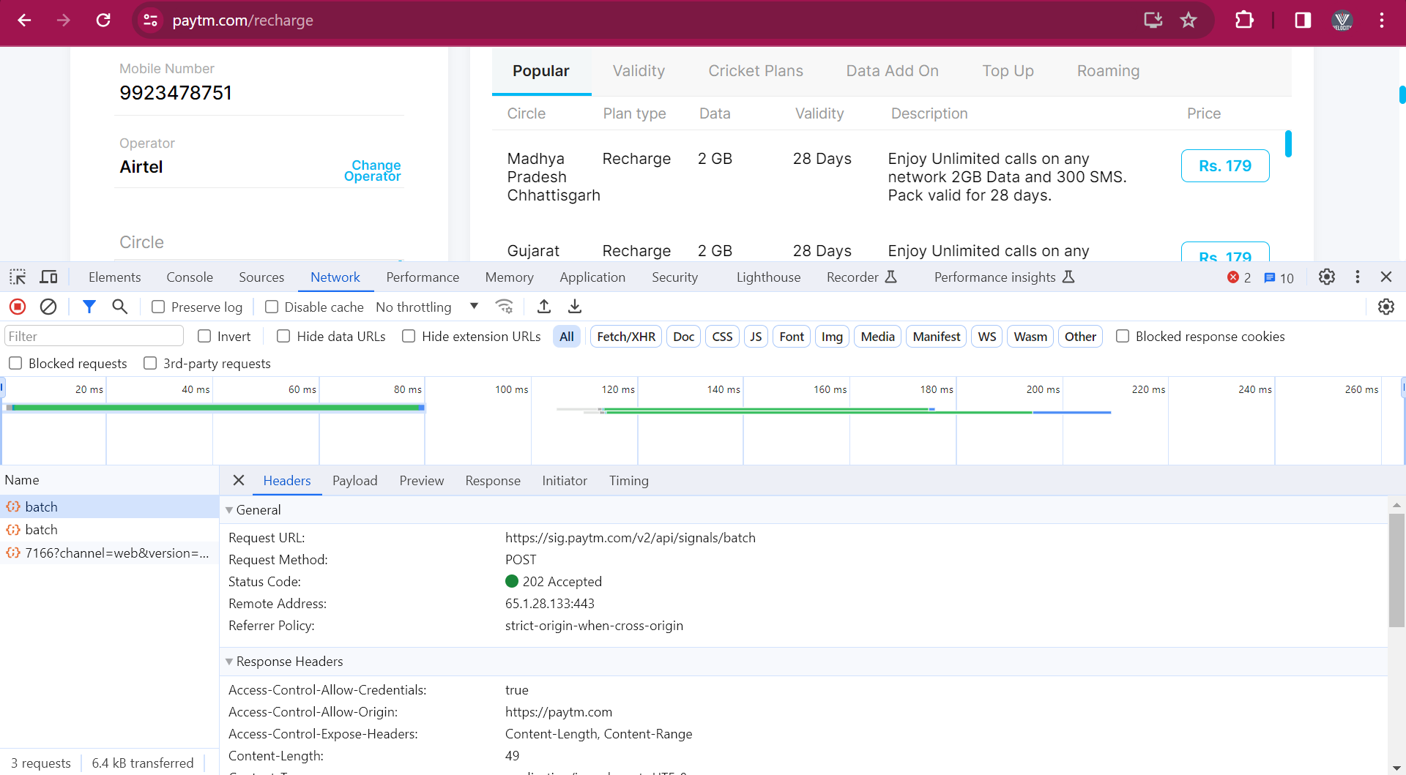

* **Database Coding** – Logical program in DB - Stored produced, functional, etc

**Testing-**

* In testing stage, tester will work
* Tester will **write test cases (TCD) & do the Test cases execution (TCE).**
* In Test cases execution, Tester will check/tetsing these implemented functionality as per requirement.
* In Test cases execution, If Tester found any issue the tester will raise the defect/ bug and inform to developer.

**Support -**

* After completion of all development & testing, these modules will send to client.
* After that these modules will provide/ handover to support team.

|  |  |  |
| --- | --- | --- |
| **Company** | **Client (USA) deployed with 1 week** | **Client (USA) deployed with 1 month** |
| Development – Bug Fix by developer | UAT – Developer | Support team developer – fix these bug |
| Testing – Bug found | UAT - tester | Support team Tester – test these bug |
| Bug | Bug | Bug |

# Waterfall Module/ process-

* Waterfall process, it is **sequential process (one after another).**
* Sequential process means after completion development /coding of all completed module then only testing will start.
* In Waterfall process, **delivery / deployment this time is not fixed/ more than 3 months.**

**Information**

**Gathering** - BRS

**Analysis –** SRS1**–** 1 module = Recharge, SRS2 – 2 modules = Insurance

**Designer** - HLD- SRS1, HLD – SRS2

**Coding** – Recharge- Bug fix + Insurance Dev X

**Testing** – TCD & TCE – Recharge- Bug

**Support** – Bug -

* In Testing – Tester has found issue/ bug – above 500rs recharge not working.
* All these bugs related to Recharge module, tester will note down and make a note (bug = 5 bug).
* When we got new module requirement then developer will do coding against the old bug fixed and new module coding.

**Dis- advantage –**

1. **Delivery / deployment** this time is **not fixed/ more than 3 months**.
2. In testing if we found bug/ issue/ defect then **backtracking (coding) is not possible.**

# V-module/ process -

* V stand for **Verification & Validation**
* V-module/ process, it is a **parallel process for development & testing.**
* In V-module/ process, **delivery / deployment** is **fixed with 3 months**.
* V-module also called as **Plane driver module (**3-month delivery).
* In V-module process, LCD (development) & LCT (testing) will do in **parallel.**

**LCD (Life cycle development)**  **LCT (Life cycle testing)**

Information gath. (**BRS**) Assessment of dev plane

Analysis (**SRS/FRS/CRS**) Prepare test plane

(SRS1- Recharge, SRS2-Movies) Requirements testing/ Doubt clear

Design – **HLD-** Wireframe Design phase testing

Coding – Developer -**LLD** Program Phase testing/

**WBT (white box testing)**

LLD – Frond, API, DB coding Test case design (**TCD** against SRS)

**Install Build (**Functionality) **TCE**-System & fun. Testing/**BBT** (Pune- Infosys)

User acceptance testing (**UAT**) - Client- USA

Knowledge transfer (**KT**) – 3-month delivery

Maintains **DRE** (defect removable efficiency) /

/Support **CR** (change request)/ **RFC/**

**Postmortem testing**

* V-module / process, Development& Testing will do Parelle
* In v-module, when BA will prepare the BRS & SRS documents then in testing stage, developer & tester will prepare a development & testing plane.
* After completion of SRS documents, then BA will send this document to project team. Project team will read or untestable the requirement. If we have problem related to the requirement then we will take one meeting with BA.
* When designer will get these SRS document then designer will prepare a HLD (prepare wireframe against that module). Then designer will give task / work to respective developer for coding.
* Developer will do LLD against the frond end, API & Database. When coding in progress then in testing stage, tester will write TCD in terms of SRS documents.
* After completion of coding then developer will do testing (WBT- white box testing). After completion development & testing, developer will send this build (module/functionality under testing) to testing.
* When tester will get this build then tester will do test cases execution. (TCE), If in TCE we found issue/ bug then we will inform to developer. Developer will fix this issue (parallel work for development & testing).
* After completion of all TCE, then tester will inform to developer. Developer will send this build into UAT environment (Client side – testing).
* After completion of all these development and testing then project team will provide KT (knowledge transfer) to support team.
* In support team will work on Ticket, Issue, CR (change request), enhancement, etc
* **DRE** (defect removable efficiency) –
* **DRE = A / (A + B)** A= No. of defect found in BBT, B = No. of defect found in UAT
* **Ex.** A = 10 defect in BBT/ Pune, B = 1 defect in UAT/ USA
* DRE = 10 / 11 = 90%
* DRE defines how much thoroughly/ deeply we have tested the application/ functionality. DRE used by PM for checking the testing activity.
* **CR** (change request)/ **RFC** (request for change) **–**
* If initially client has given some requirement after development and testing. When developer completed and delivery to client. Then client want some small changes then client sent the **CR (changes request).** CR will get from client by email.
* **Ex**. 5 Requirement in V-module – 3-month coding, testing & delivery to client – 1cr taken from client. If Client want some changes in completed/ developed then client sent CR (change requirement). For every CR company will charge to client.
* CR also called as **RFC** (request for change)
* **Postmortem testing –** Before deployment to client, in company tester will test the functionality/ build in with main functionality in the application, these testing will call as **Postmortem testing.**

**V-process dis-advance –**

* In V-module, **delivery & deployment with 3 months**, it not good from client perspective.
* In V-module, if any change comes from client side (CR), for every CR company will charge to client.

# Basic SDLC** –

Information Analysis Design Coding Testing Support

Gathering (**BRS**) (**SRS**) (**HLD-** wireframe) (**Developers-** LLD) **TCD, TCE**

Review (**BA**) Review (**BA**) Review (**Design**) **WBT** (White **BBT** (Black

Box testing) box testing)

Static testing/ Verification / Dynamic testing / Validation /

Quality assurance Quality Control

* **Review –** In Review, to check **correctness & completeness of your own documents**.

|  |  |
| --- | --- |
| **WBT (White box testing)** | **BBT (Black box testing)** |
| In WBT, **developer** will work | In BBT, **Tester** will work |
| In WBT, Developer will check their logical program, loop statement, condition statement, branches statement, etc | In BBT, tester will check different coverage – Input domain coverage, Error handling, Calculation based coverage etc |
| WBT also called as **Code level testing** | BBT also called as **system & functional testing** |
| WBT two types,   1. **Unit Testing** 2. **Integration testing** | BBT two types,   1. **Functionality testing** 2. **Non- Functionality testing** |
| Developer will see the code related that functionality/ module, that why WBT called as White box | Tester can’t see the code related that functionality/ module, that why BBT called as Black box |

|  |  |
| --- | --- |
| **Static testing/ Verification** | **Dynamic testing / Validation** |
| In Verification, BA will check their own documents, Designer will check their design, Developer will check their code | In Validation, Tester will work. Tester will check functionality as per requirement documents/ SRS documents |
| Verification also called as Static testing | Validation also called as **Dynamic testing** |
| Verification also called as In-progress testing | Validation also called as End- progress testing |
| In verification, quality assurance will comes define (coding will as per design). | In validation, we will define quality of the application/ module/ functionality (quality control) |

# Agile process (90 to 95%) ** -

* Agile it is iterative process (same work will done with some time period)
* it is **continuing process for development, testing & deployment** **with 2 weeks.**
* In Agile, **Delivery / Deployment to the client with 2 weeks (Server company**)/ 3 week (product-based company).
* When **any CR comes from the client these we will accept at any point of time**. If that requirement under development or under testing or under production/ Live. After accepting these requirement **PM will discuss with client.**

1. If **CR has less impact** on current development, current testing and application which is present product/ live then these CR we will consider in **current sprint.**
2. If **CR has less high impact** on current development, current testing and application which is present product/ live then these CR (client ask these CR has less important) we will consider in **next sprint OR** if CR (client ask these CR has more important) we will consider in **current sprint.**

* Agile process also called as **Values driver process** (Client priority will consider).
* Agile contain multiple framework / sub-module/ methodologies/ sub-types

1. **XP** (extreme programming) – only coding and not testing
2. **Scrum** – **Sprint** (bunch of requirements) **wise delivery with 2 weeks.**
3. **Kanban** – used for support team (bug, ticket, end user quires, CR, Ench., etc)
4. **Lean** - used for support team (bug, ticket, end user quires, CR, Ench., etc)
5. **FDD** (future driver development)- developed the application by considering future requirements from the client.

* I have worked in **scrum agile framework/ sub-module/ methodologies.**
* Ex. 1 module = 30 requirement / Use cases =
* Current work 1 = 2 week = 5 requirement / Use cases – Dev + Testing + Delivery
* Current work 2 = 2 week = 4 requirement / Use cases - Dev + Testing + Delivery
* Current work 3 = 2 week = 6 requirement / Use cases - Dev + Testing + Delivery

CR – Less impact – current work.

CR – more impact – 1 . Client high important – current work.

2 . Client less important – next work.

## Agile architecture-

**Information Product backlog** (1 SRS – 20 US,

**Gathering** (BRS) 2 SRS – 90 US, 3 SRS = 48US) = 208 US

**Analysis Sprint backlog (2-week delivery)**

(SRS – Module 1- existing Recharge – 4 req.) Sprint 1 = 9 US – combine module US

(SRS – Module 2- Movies – 15 req.) Sprint 2 = 8 US – Dev + Test + Delivery

(SRS – Module 3- Insurance – 8 req.) Sprint 3 = 10 US – Dev + Test + Delivery

Existing module Req. = 1 req. = 4US Sprint 4 = 8 US – Dev + Test + Delivery

**Use Cases /1 requirement** 🡪 BA convert 🡪 **User Stories** (1req. = 6 US)

1. Description 1. Description

2. Acceptance criteria 2. Acceptance criteria

Designer Designer – Design against the US

Coding – LLD against the US

Testing – TCD & TCE against the US

* BA will prepare SRS documents for every new module and for existing module. BA people will convert these all-SRS documents requirement/ Use cases into User stories.
* These all-User stories will add into product backlog.
* **Product backlog** – Bunch of user stories/ small work related to your project/ application which added into project management tool (JIRA/ Azure DeVos tool)
* All user stories which is present in product backlog will be added into sprint backlog. Sprit backlog user stories will decide by client (client priority/ values driven process).
* **Sprint** **backlog –** Bunch ofuser stories which will be developed, tested & deployed with 2 weeks to client.
* In sprint backlog, all these user stories will Developed, Tested & Deployed with 2 weeks.
* Designer will design the functionality accordingly to user stories and developer will do coding against the user stories.
* Tester will write test cases accordingly to user stories and TCE accordingly user stories.

**Product Backlog-** 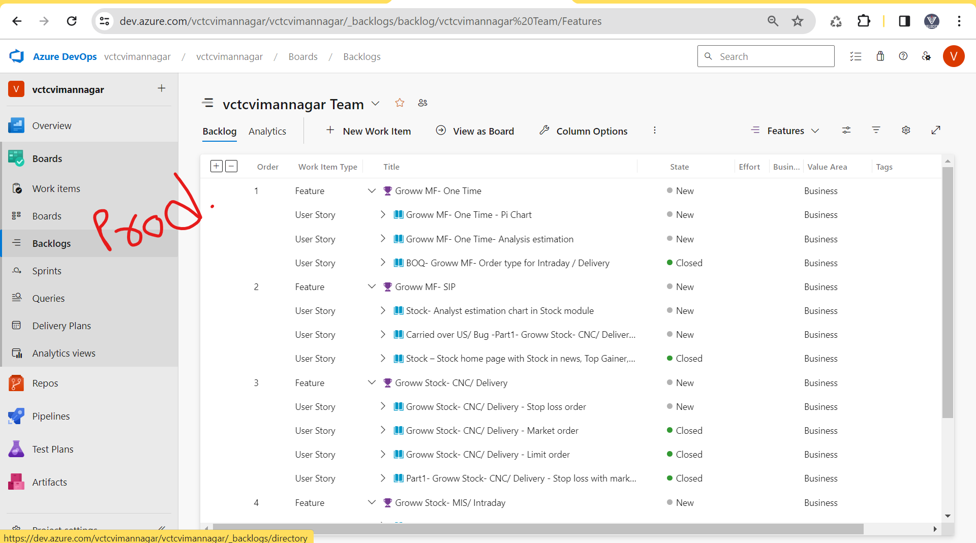

**Sprint Backlog-** 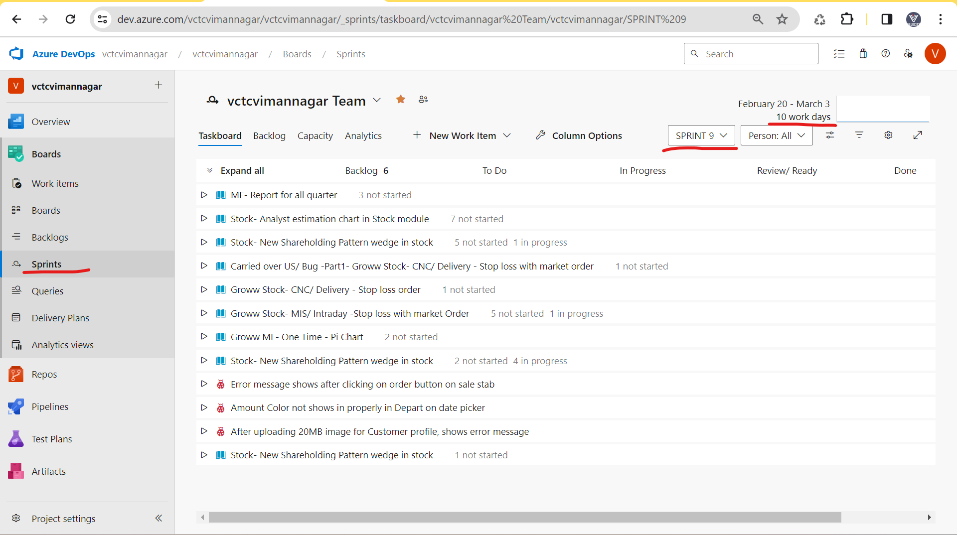

**User stroies-** 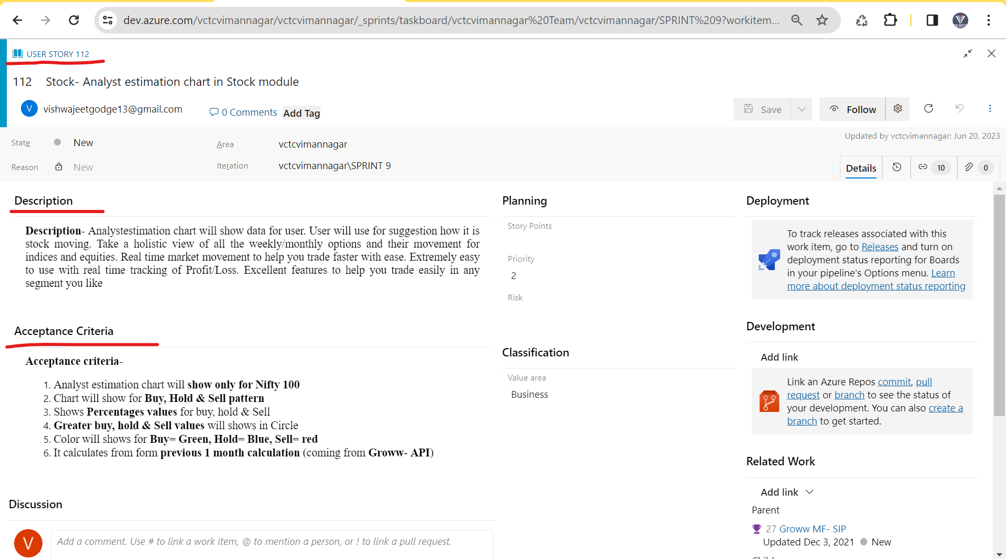

## Agile Meeting/ Agile Ceremonies** –

* In agile we have different types meeting

1. Sprint planning meeting
2. Grooming meeting
3. Daily stand-up meeting
4. Sprint review meeting
5. Sprint retrospective meeting

|  |  |  |
| --- | --- | --- |
| **Meeting** | **Purpose** | **Involvement** |
| **Sprint planning meeting**  1 day of sprint  Time = 10 am to 11am | 1. In current sprint decide how much requirement/ work consider  Ex. Sprint 1 = 8 req. – 2-week deployment  Ex. Sprint 2 = 9 req. – (3 req. = Me)  Ex. Sprint 3 = 7 req.  2. Task/work allocation & decide the estimation/ story point against the requirement  Ex. 1 req. = 18hr Dev + 10hr Testing  Ex. 2 req. = 24hr Dev + 14hr Testing  Ex. 3 req. = 16hr Dev + 14hr Testing | **1hr – PM,** BA, Designer, Dev Team, Testing Team |
| **Grooming meeting**  Conduct at any of time | 1. Current work/ req. against if we have doubt/ clarification from BA | **1hr/30min – BA**, PM, Designer, Dev Team, Testing Team |
| **Daily Stand-Up Meeting/ Scrum meeting**  Every day at 10.00am (10am to 10.15am) | Daily work progress for each person   1. What you have done yesterday 2. What you are doing today 3. Issue / Roadblock | **15Min – PM,** BA, Designer, Dev Team, Testing Team |
| **Sprint review meeting**  Last day of sprint  (3 to 4pm) | Tester will give **Demo/ Review** of tested requirement to **Client/ UAT Tester/ BA** | **1hr – Client/ UAT Tester/ BA,** PM, Designer, Dev Team, Testing Team |
| **Sprint retrospective meeting**  Last day of sprint  (5 to 5.30pm) | Current sprint 1 – good & bad discuss related to work done in sprint 1  Current Sprint 1 – Next Sprint 2 | **30Min/ 1hr – PM,** BA, Designer, Dev Team, Testing Team |

## Scrum Agile Daily wise plane** –

* Project team = 16 peoples in 8/9 developer and 3 Tester
* **Current sprint 10 = 8 US** (3 different module – 3US Recharge module, 2 US – Movies module, 3 US – Insurance module)
* **Team 1** – 3 developers (Frond, API, DB) + **1 Tester (Me) = 3US Recharge module**
* **Team 2** - 3 developer (Frond, API, DB) + 1 Tester = 2 US – Movies module
* **Team 3**- 2 developer (Frond, DB) + 1 Tester = 3 US – Insurance module
* **2-week sprint – 10 days** = 1 days * 8hr/ person = 80hr – In sprint maximum a person will work 80hr (real work in company = 50hr/ person).

**Project** = SRS = 10 req., SRS = 20 req.🡪 BA convert into User stories

**Product backlog** (US = 60US + 90US)

**Sprint backlog**

**Sprint 1 = 6US** – 2week dev + Test+ delivery (US will decide accordingly to client priority)

Sprint 2 = 7US – 2week dev + Test+ delivery

Sprint 3 = 9US – 2week dev + Test+ delivery

Sprint 4 = 8US – 2week dev + Test+ delivery

Sprint 5 = 7US – 2week dev + Test+ delivery

**1 week of Sprint- (Monday to Friday)**

**Monday (1st Day of Sprint) (office working time = 9.30am to 6.00pm)**

* **Sprint Planning meeting (Time 10 am to 11am)-**

1. In current Sprint 1 = 8 US will take that will discuss for Dev + Test + development (3US = Tester me allocated)
2. Task/work allocation & decide the estimation against the US (1 US = 18hr Dev + 10hr Testing)

* **Grooming Meeting (Time 11am to 11.30am)**

1. If we doubt against the US which is allocated (Team 1 has doubt). (If I have problem in US then we will first discuss with team lead/ tester member. If team lead also have problem, then we will conduct grooming meeting)

* **Daily work** – Team 1 = 3 developer + 1 Tester (3US – Recharge module)
* 3 Developer – 1US coding (14hr) – In-progress
* 1 Tester – 1US TCD (5hr) – Complete

**Tuesday - (office working time = 9.30am to 6.00pm)**

* **Scrum meeting/ daily stand-up meeting (Time = 10am to 10.15am)**

1. What you have done yesterday (Tester – 1US TCD – Complete)
2. What you are doing today (Tester – 2US TCD – Start)
3. Issue / Roadblock

* **Daily work** – Team 1 = 3 developer + 1 Tester
* 3 Developer – 1US coding (16hr) – In-progress
* 1 Tester – On 2US tester will do TCD (5hr) – In-progress.

**Wednesday - (office working time = 9.30am to 6.00pm)**

* **Scrum meeting/ daily stand-up meeting (Time = 10am to 10.15am)**

1. What you have done yesterday (Tester – 2US TCD – In-progress)
2. What you are doing today (Tester – 2US TCD – End & 3US TCD - Start)
3. Issue / Roadblock

* **Daily work** – Team 1 = 3 developer + 1 Tester
* 3 Developer – 1US coding (10hr) – Completed + 1US build sent for testing + 2US coding (8hr) - In-progress.
* 1 Tester – On 2US tester will do TCD (3hr) – Completed + Tester will do TCE on 1US build (3hr) - In-progress.

**Thursday - (office working time = 9.30am to 6.00pm)**

* **Scrum meeting/ daily stand-up meeting (Time = 10am to 10.15am)**

1. What you have done yesterday (Tester – 2US TCD – completed + 1US TCE - In-progress)
2. What you are doing today (Tester – 1US TCE - Continue)
3. Issue / Roadblock

* **Daily work** – Team 1 = 3 developer + 1 Tester
* 3 Developer - 2US coding (16hr) - In-progress
* 1 Tester – Tester will continue TCE on 1US build (7hr) – completed.

**Friday - (office working time = 9.30am to 6.00pm)**

* **Scrum meeting/ daily stand-up meeting (Time = 10am to 10.15am)**

1. What you have done yesterday (Tester –1US TCE - Completed)
2. What you are doing today (Tester – 3US TCD - Start)
3. Issue / Roadblock

* **Daily work** – Team 1 = 3 developer + 1 Tester
* 3 Developer - 2US coding (12hr) – In-progress
* 1 Tester – Tester will start 3US TCD (4hr) – In-progress.

**2-week (Monday to Friday)-**

**Monday - (office working time = 9.30am to 6.00pm)**

* **Scrum meeting/ daily stand-up meeting (Time = 10am to 10.15am)**

1. What you have done yesterday (Tester –3US TCD - In-progress)
2. What you are doing today (Tester – 3US TCD – try to complete)
3. Issue / Roadblock

* **Daily work** – Team 1 = 3 developer + 1 Tester
* 3 Developer - 2US coding (16hr) – complete + 2US build sent for testing.
* 1 Tester – Tester will start 3US TCD (4hr) – complete.

**Tuesday - (office working time = 9.30am to 6.00pm)**

* **Scrum meeting/ daily stand-up meeting (Time = 10am to 10.15am)**

1. What you have done yesterday (Tester –3US TCD - complete)
2. What you are doing today (Tester – 2US TCE – start)
3. Issue / Roadblock

* **Daily work** – Team 1 = 3 developer + 1 Tester
* 3 Developer - 3US coding (16hr) – In-progress + 2 Bug will fix (1hr)
* 1 Tester – Tester will start 2US TCE (6hr) – Continue / In- progress.
* 2 Bug/issue/ defect found then we will inform developer + Tester will do the testing - 2 Bug / issue/ defect (1hr).

**Wednesday - (office working time = 9.30am to 6.00pm)**

* **Scrum meeting/ daily stand-up meeting (Time = 10am to 10.15am)**

1. What you have done yesterday (Tester –2US TCE – In-Progress & 2 bug raised & tested)
2. What you are doing today (Tester – 2US TCE – Try to complete)
3. Issue / Roadblock

* **Daily work** – Team 1 = 3 developer + 1 Tester
* 3 Developer - 3US coding (14hr) – In-progress
* 1 Tester – Tester will start 2US TCE (6.30hr) – Completed.

**Thursday - (office working time = 9.30am to 6.00pm)**

* **Scrum meeting/ daily stand-up meeting (Time = 10am to 10.15am)**

1. What you have done yesterday (Tester –2US TCE – completed)
2. What you are doing today (Tester – 3US TCE – Start)
3. Issue / Roadblock (but we don’t get the build)

* **Daily work** – Team 1 = 3 developer + 1 Tester
* 3 Developer - 3US coding (6hr) – completed + 3US build sent for testing + 4 bug developer fixed & 2 bug not accepted.
* 1 Tester – Tester will start 3US TCE (5.30hr)- Continue/ In-progress + 4 bug / defect re-tested (1.30hr).
* 6 Bug/ Defect found and inform to developer.

**Friday – Last day of Sprint (office working time = 9.30am to 6.00pm)**

* **Scrum meeting/ daily stand-up meeting (Time = 10am to 10.15am)**

1. What you have done yesterday (Tester –3US TCE – In-progress & 6 defect raised)
2. What you are doing today (Tester – 3US TCE – we will complete before demo)
3. Issue / Roadblock (developer has fixed 4 defect/bug but 2 defect/bug not accepted)

* **Daily work** – Team 1 = 3 developer + 1 Tester
* 3 Developer - 3US coding (6hr) – 2 defect/bug fixed (3hr).
* 1 Tester – Tester will start 3US TCE (5.30hr)- Completed + 2 defect/bug will re-tested.
* **Sprint review meeting (Time = 4pm to 5am)**

1. Tester (Me = 3 US recharge) will give the demo/ review to Client/ UAT Tester / BA.

* **Sprint retrospective meeting (Time = 5.30pm to 6.00pm)**

1. Sprint 1 = 8US – worked – Good & Bad happed will discussion.
2. In next sprint 2 working in next week. Good – work continue, Bad work.

**Sprint 2- 7 US (Me = 3US)**

|  |  |  |  |  |  |
| --- | --- | --- | --- | --- | --- |
| **1 Week** | | | | | |
| **Days** | **Monday** | **Tuesday** | **Wednesday** | **Thursday** | **Fridays** |
| **Meeting** | Sprint planning meeting (1hr)  Sprint 2 = 7US, Task/ work allocation + Estimation | Daily Stand-up meeting (15min) | Daily Stand-up meeting (15min) | Daily Stand-up meeting (15min) | Daily Stand-up meeting (15min) |
| **3 Developer** | 1US – Coding (14hr) – In-progress | 1US – Coding (16hr) – In-progress | 1US – Build sent to Testing(1hr) + 2US – Coding (10hr) – In-progress | 2US – Coding (15hr) – In-progress + 2 Bug/ Defect fixed (2hr) | 2US – Coding (18hr) – In-progress |
| **1 Tester** | 1US – TCD (4hr) - In-progress | 1US – TCD (5hr) - Completed | 1US – TCE (6hr) – In-progress | 1US – TCE (6hr) – TCE – Completed +2 Bug / defect raised - & 2 Bug testing (1hr) | 2US – TCD – Start (4hr) – In-progress |
| **2 Week** | | | | | |
| **Days** | **Monday** | **Tuesday** | **Wednesday** | **Thursday** | **Fridays** |
| **Meeting** | Daily Stand-up meeting (15min) | Daily Stand-up meeting (15min) | Daily Stand-up meeting (15min) | Daily Stand-up meeting (15min) | Daily Stand-up meeting (15min)  Sprint Review Meeting (1hr)  Sprint retrospective meeting (30min) |
| **3 Developer** | 2US – Coding + 2 US build sent to testing (18hr) | 3US – Coding (14hr) – In-progress + 3 Bug (2US) fixed (3hr) | 2 Bug (2US) fixed (2hr) + 3US – Coding (14hr) – In-progress | 3US – Coding (14hr) – In-progress & 3SU build sent to testing. | 4 Bug fixed (3hr) |
| **1 Tester** | 2US – TCD – (6hr) – Completed | 2US – TCE (6hr) – In-progress + 5 Bug raised + 3 bug tested (1hr) | 2US – TCE (6hr) – In-progress & completed + 2 Bug tested (1hr) | 3US – TCD (4hr) – Start & completed + 3US – TCE (3hr) – Start & In-progress | 3US – TCE (1hr) – Started & 4 Bug raised & Continue TCE (5hr) – completed + 4 Bug tested (1hr) |

**Sprint 3- 6 US (Me = 2US) -**

|  |  |  |  |  |  |
| --- | --- | --- | --- | --- | --- |
| **1 Week** | | | | | |
| **Days** | **Monday** | **Tuesday** | **Wednesday** | **Thursday** | **Fridays** |
| **Meeting** | Sprint planning meeting (1hr)  Sprint 3 = 6US, Task/ work allocation + Estimation | Daily Stand-up meeting (15min) | Daily Stand-up meeting (15min) | Daily Stand-up meeting (15min) | Daily Stand-up meeting (15min) |
| **3 Developer** | 1US – Coding (14hr) – Started & In-progress | 1US – Coding (16hr) – In-progress | 1US – Coding (18hr) – In-progress | 1US – Coding (14hr) – In-progress | 1US – Coding In-progress & 1US build sent to testing (14hr) - Completed |
| **1 Tester** | 1US – TCD (5hr) – Started & In-progress | 1US – TCD (6hr) - Started & Completed | 2US – TCD (5hr) – Started & In-progress | 2US – TCD (4hr) – In-progress | 2US – TCD (2hr) – Completed |
| **2 Week** | | | | | |
| **Days** | **Monday** | **Tuesday** | **Wednesday** | **Thursday** | **Fridays** |
| **Meeting** | Daily Stand-up meeting (15min) | Daily Stand-up meeting (15min) | Daily Stand-up meeting (15min) | Daily Stand-up meeting (15min) | Daily Stand-up meeting (15min)  4 bugs clarification/ discussion  Sprint review meeting (1hr)  Sprint retrospective meeting |
| **3 Developer** | 2US – Coding (14hr) – Started & In-progress + 2 bug fixed (2hr) | 3 bugs fixed (2hr) + 2US – Coding – Started & In-progress | 2US – Coding – Started & In-progress + 2US build sent to testing | Developer code coverage checking (1hr) + 4 bug fixed (4hr) & 4 bugs doubt | 4 bugs fixed (3hr) |
| **1 Tester** | 1US – TCE (1hr)– Started + 5 bug raised + 1US – TCE – continue (6hr) - In-progress | 1US – TCE (5hr)– In-progress + 5 bugs tested (3hr) | 1US – TCE (3hr)– In-progress & completed + 2US – TCE (2hr) – Started & In -progress | 2US – TCE (2 hr) – Started + 8 bugs raised + 2US – TCE – continue (5hr) - In-progress | 4bug tested (2hr) + 2US – TCE (2 hr) – completed + 4 bugs tested (2hr) |

## Agile people –

**SDLC Agile name**

* Client 🡪 Stake holder
* Delivery Manager 🡪 Solution master
* Business annalist 🡪 Product owner
* Project Manager 🡪 Scrum master
* Designer 🡪 Designer
* Developer 🡪 Developer
* Tester 🡪 Tester

## Agile Terms** –

* **Sprint refinement meeting-** In sprint refinement meeting **DM, PM, BA, Designer & Client** will be present. In sprint refinement meeting they will **decide the planning of next sprint**. Client will decide which US will take into next sprint. (Value drive process)
* **Ex.** Current Sprint 2- 7US – In **2 weeks on Wednesday/** Thursday, sprint refinement meeting will be conducted. In these meeting, decided the US which will be added into the Next sprint 3 = 8US.
* **Ex.** Current Sprint 3- 8US – In 2 weeks on Wednesday/ Thursday, sprint refinement meeting will be conducted. In these meeting, decided the US which will be added into the Next sprint 4 = 7US.
* When sprint started then PM will conduct the Sprint planning meeting – On current sprint 4 how much US we have taken = 7US. In sprint planning meeting, PM will create/ assign task/ work and ask estimation against that task/ work.
* **Epic –** Parent US which is present in the product backlog for a module. Ex. SRS = Movies ticket module = 10 Req. / Use cases. BA will convert all these use cases into Use stories. BA will prepare the epic in product backlog and add all these User stories into that epic.
* Ex. Epic (parent User stories) = Movies Ticket – 60 Use stories (child US).
* **Product backlog** – Bunch of user stories/ small work related to your project/ application which added into project management tool (JIRA/ Azure DeVos tool). All user stories which is present in product backlog will be added into sprint backlog. Sprit backlog user stories will decide by client (client priority/ values driven process).
* **Sprint** **backlog –** Bunch ofuser stories which will be developed, tested & deployed with 2 weeks to client.
* **Burn down chart –** Burn down chart define how much work will pending with respect to time. These Burn down chart will be present in Project management tool.
* **Burn Up chart –** Burn up chart define how much work will be completed with respect to time. These Burn down chart will be present in Project management tool.
* **Velocity chart –** Velocity chart defines how much work we are delivery in every sprint to client **OR** how much estimation we have given and how much actually we requirement while working.

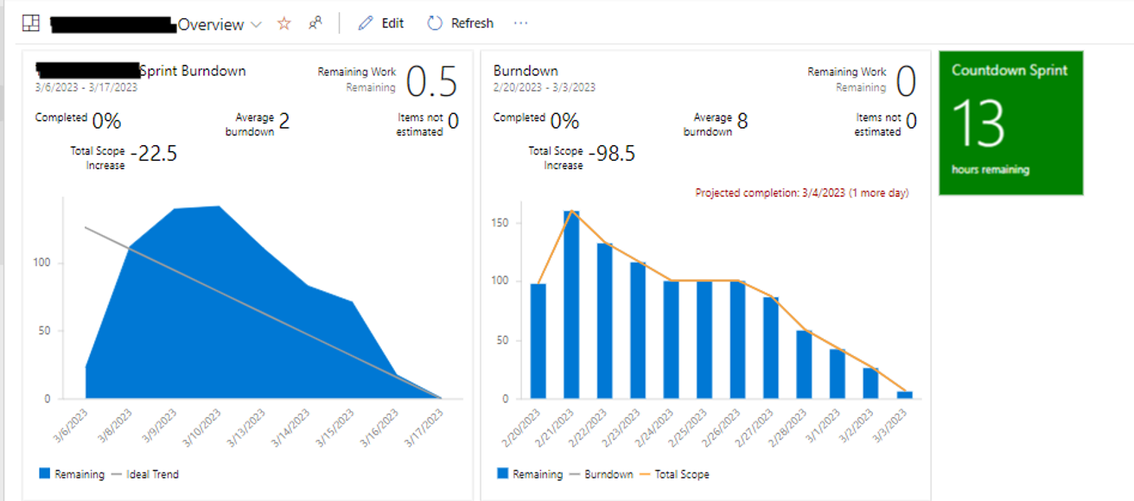

* **Estimation -** In sprint planning meeting, PM will give or assigns task/work to every developer & tester. PM has assigned task TCD & TCE to Tester (me). PM will ask estimation. Estimation is nothing but time to complete the work/ task.
* **Estimation will give by consider points,**

1. How much knowledge you have about the US.
2. How much efforts will be required for testing.
3. How much complex the US. (Ex. Testing = Order PDF check – 1 item, 2 item, 3 item, 4 item …… 20 items.)

* In real project, PM already will give rough estimation to task/ work. PM confirmation these time from tester.

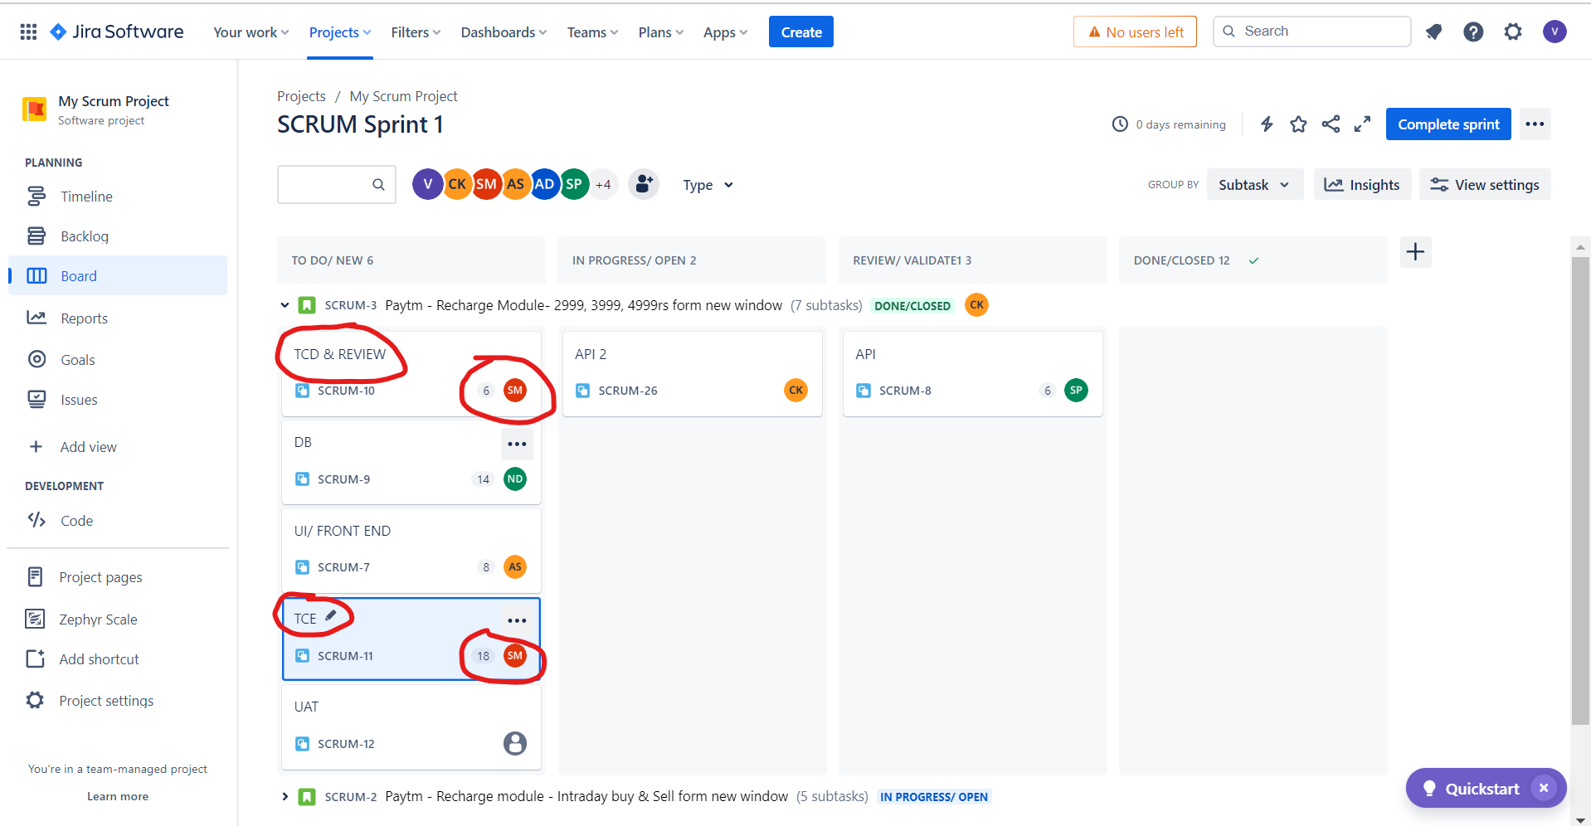

* **Story point –** The time which is given to US in term of points that ids called as story points. Accordingly, to Story points, company will charge to the client.
* **Ex**. 1US (Story point = 5 points = 40hr/8hr = 5 days = Development = Front end task (8hr- estimation) + API task (6hr) + DB test (8hr) + Testing = TCD (6hr- estimation) + TCE (12hr- estimation).



* **Scrum of scrum meeting- Main manager or scrum of scrum master** will conduct one meeting with all PM, these meeting are called scrum of scrum meeting.
* **Ex**. Project = [One97 Communications](https://www.google.com/search?sca_esv=9fc63cc73e9e59b8&rlz=1C1ONGR_enIN1071IN1071&q=One97+Communications&si=AKbGX_qWtsfHufXsq_1jeDkJp50FstNngDxsch3EVTUjn7imcH-qO5s2Te55-BjPkSZkYrlswlR5uOpkfbENZPBM6hRBnaJgGirhVsLd1L8JJrAPCOrA-Tryh_Q3rPhKcOR46bCWB1-DN_Cex6xu9cuwyJO8wJhKuVK16hdbv_umuXH2i25H14cAZaSLQkp5D7eQIrIzwm4UlJoJKl4WCQoWOYI51Q9kRA%3D%3D&sa=X&ved=2ahUKEwisvLWU9d-EAxXTm68BHTFKDZwQmxMoAXoECF8QAw)–

**1 module – Reacher module**

**2 Module – Movies module** [**www.paytm.com**](http://www.paytm.com) **– project Team = 16 - PM1**

**3 Module – Fasttag module**

**4 Module – Stock market -**

**5 module – IPO www.paytmmoney.com – project Team = 25 – PM2**

**6 Module – MF buy/sell**

**7 module -**

**8 module –** [**https://paytmmall.com**](https://paytmmall.com) **- project Team = 30 – PM3**

**9 module -**

* PM1, PM2 & PM3 will be report to main project manager/ Scrum of scrum master.

## Agile Principles/ Agile Manifesto** -

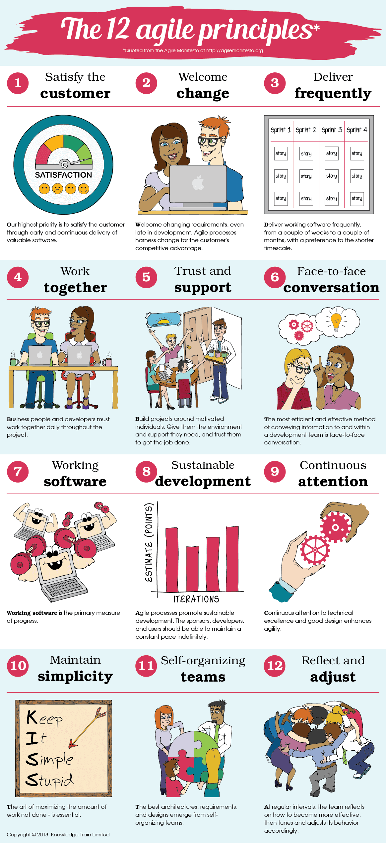

1. **Customer satisfy** – by doing deployment with 2 weeks.
2. **Well come changes** – Any CR comes at any points then we will accept these CR in current sprint.
3. **Delivery frequency –** Sprint wise delivery with 2 weeks.
4. **Work Together –** US work will be taken by = Development + Testing + Deployment done by developer.
5. **Trust & Support –** Trust & support will get within a team.
6. **Face to Face conversion –** InDaily stand-up meeting
7. **Working software –** In demo we are giving demo/ review to working application and same will be deployed to client.
8. **Sustainable development –** In every sprint, we are delivery 6US, In next sprint 7US, in next sprint 8US, in next sprint 9US, etc. For sustainable development we will check velocity chart.
9. **Continues attention –** iterative process / continues process for development and testing and development.
10. **Maintain simplicity –** US – work decide – Frond end, API, DB & Testing.
11. **Self-organized –** In daily stand-up meeting. (If developer completed the build, then tester immediately start the TCE)
12. **Reflect & Adjustment –** Functionality implement developer Frond end work + API work + DB work will adjust work accordingly.

**Scrum board-** 

**Kanban board-** 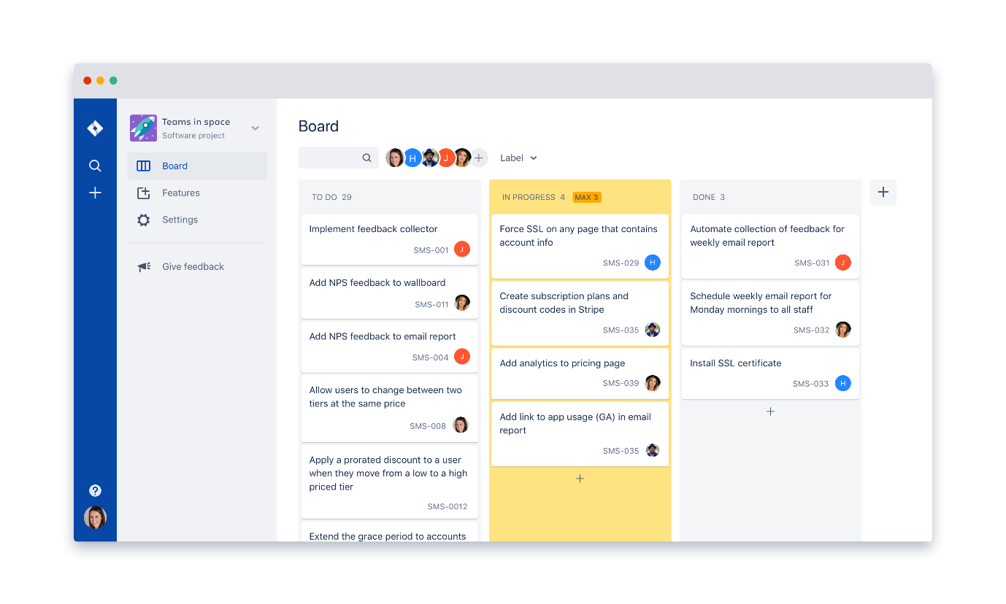

|  |  |
| --- | --- |
| **Scrum Board** | **Kanban Board** |
| Project team will work in scrum board. | Support team will work in Kanban board. |
| Project team always work in US | Support team always work in Bug, end user Quires, Ticket, Enhancement, CR, etc |
| After completion of all US in a current sprint, we will delivery to client | After completion of all Bug/ end user Quires/ Ticket/ Enhancement/ CR, etc in a current sprint, we will delivery to client |
| Delivery with 2 weeks. | Delivery with 2 weeks which has completed Bug/ end user Quires/ Ticket/ Enhancement/ CR, etc |

## Agile Advantages & Dis-advances-

**Advantages -**

1. In agile we will delivery US with 2 weeks.
2. If any CR comes then we will accept at any point accepted.
3. Daily wise meeting / Scrum meeting – to discuss daily work progress.
4. Automation is possible over in sprint.

**Dis-Advantages -**

1. If any frequent changes occurred in the US/ requirement becz very difficult to complete work with 2 weeks.
2. If we have dependency one module into another module.

PVR, INOX, etc – Module

Bank – SBI, ICIC, Axis, etc

Paytm –

Movies module,

UPI module

**Interview question -**

1. What is your team size OR tell me how many people are present in your last project.
2. What is SDLC and what contain in SRS documents?
3. What is V-module & What are disadvantages?
4. What is Verification & Validation?
5. What is WBT & BBT?
6. What is Agile, Scrum, Sprint?
7. What are agile ceremonies/ meeting?

* **Answer** – 5 meeting names.

1. What are you doing in daily stand-up meeting?

* Answer – In project we are conducting daily stand up at 10 am to 10.15 am. PM will ask everyone about their work progress.

1. What you have done yesterday
2. What are doing today.
3. Are you facing nay issue/ roadblock.
4. What have you discussed in your retrospective meeting? OR What you have done in your last retrospective meting?

* **Answer**- In retrospective meeting, we have discussed about the good and bad thing which has been done in current sprint.
* Discussion points- (Ex. Login page – Mobile no should be accepted +91, +84, +11, etc.
* Good points – Tester has done good testing by considering business requirement.
* Good points – Tester has good knowledge about the US/ requirement.
* Bad points – US is not complete, difficult to do coding.
* Bad points – Developer need considered or understand US/ requirement correctly.

1. What is your daily routine in your last project? OR how you are working in last project?

* **Answer** – In my project we are following scrum agile methodology.
* **In 1st day** – we are conducting sprint palling meeting – PM explain about US in current sprint (sprint 5= 8US) and work/task allocation for developer & tester. PM ask about the estimation for respective task.
* If we doubt then we will conduct grooming else we will start the TCD for respective US. When we got the build from developer then we will do TCE.
* If we found defect in TCE then we will inform to developer. If developer has foxed the bugs, then we will re-test these bugs.
* On every daily we will follow daily stand-up meeting.
* This work will be conducted until all US is completed which is allocated to me.
* In last day of sprint, we will conduct sprint review meeting (demo to client/ UAT team) and also, we will conduct sprint retrospective meeting.

1. What is Burn down chart, Burn up chart, Velocity?
2. What is sprint refinement meeting/ Sprint zero meeting?

* Answer- In sprint refinement meeting **DM, PM, BA, Designer & Client** will be present. In these meeting, they will **decide the planning of next sprint**. According to Client will priority, we will take US from product backlog into sprint backlog.

1. What is scrum of scrum meeting?
2. When are you doing deployment of your US of current sprint?

* Answer – In my project, Developer will do the **deployment on early morning on Saturday (Time = 9am to 11am)** / On Monday (Time = 9am to 10am) of next sprint.

1. What are your approaches, if one US is not completed in of current sprint? **OR** what is an approach, if some defects are not fixed of current US **OR** if we have deployment in next day but defect not fixed, or US id not tested? **OR** if some defects are not fixed or take more time to fixed and you have done deployment in couple of hours, what is your approaches**?

* **Answer –** We will try to complete this work (pending TCE) in current sprint only. I will extend my work / I will work on late night (Friday up to 11pm to 1am) and try to complete the work.
* If it will not be completed, we will inform to your Test lead/ PM regarding these. (then Test lead/ PM will distributor your work with your testing team)
* If some bug/ or TCE is pending, then your PM will discuss with client and add this work (pending Bug/ pending TCE) into next sprint. In next sprint this work will defines as “Carried over Bug / Split over US” This work will deploy in current sprint.

1. **Story Points** – Give to US. Points – 1 pointer story, 2 pointer story, 3 pointer story, 5 pointer story, 8 pointer story, 13 pointer story
2. What is Beta version?

* **Answer**- When application / build is released.

1. What are advantages of agile and dis- advantages?
2. Which US you have tested in your last project? OR what is US you have tested?**
3. What you have discussed in your last retrospective meeting?
4. What is last defect you have raised in your project?

# Project Technology/ techniques/ Languages** –

* **In my Project**, we have **3 different technologies.**
* **Frond end / UI 🡪 React framework (JavaScript, HTML, CSS)**
* **Database 🡪 SQL server**
* **API / Services 🡪 Dot Net Languages (. Net)**

**Database** **–** Database Testing - Manual Testing

**FROND END/ UI –** Manual & Automation Testing

**API/ Service –** Manual API Testing & Automation Testing (Rest assured)

**Other application - Phone Pay - API/ Service –** Payment – UPI ID

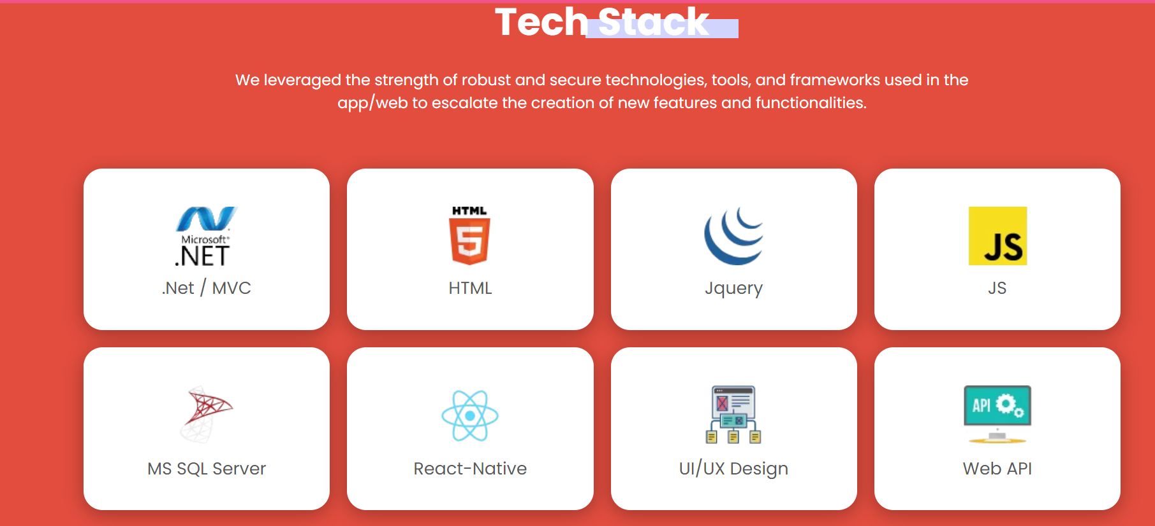

**Database –** Store producer (SP) hit – Mobile Phone

Request

**Frond End/ UI/ GUI –** Flipkart - Mobile link

**API/ Service –** GET request & Fetch response

Response

# Project Environments/Servers** –

* **In my project, we have 4 types of environments present.**

|  |  |  |  |
| --- | --- | --- | --- |
| **Environment** | **Used** | **URL** | **Next** |
| **Dev environments** | Developer used these environments – Dev will do WBT testing/ Unit Testing. | **URL = 172.10.21.161:8080/icic.com** | When developer will be completed all WBT then developer sent build to tester into SIT/QA/ Test env. |
| **SIT / Test / QA environments** | Tester used these environments for testing (BBT/ System & functional testing) | **URL = 192.20.60.141:8085/icic.com** | After TCE completed, tester will inform to developer. |
| **UAT/ Pre-prod environments** | UAT tester will do testing | **URL = 192.10.62.190:8080/icic.com** |  |
| **Prod/ Live environments** | End user, use these the new module / functionality | **URL = www.icic.com** |  |

* **Company** – **Infosys, Pune** – Development environments (Dev env.) + Testing environments (SIT/ Test env.)
* **Client, USA** – UAT/ Pre-prod/ Stagging (User acceptance testing) + Production / Live environments (Prod env.)

**Prod/ Live environments.**

**Existing App = 2000 code +**

**1US = 560 line**

**Dev environments**

Existing App = 20,000 code +

1US = 560 line

**SIT / QA/ Test environments.**

**Existing App = 20,000 code +**

**1US = 560 line**

**UAT/ Pre-prod/ Staging env.**

**Existing App = 20000 code +**

**1US = 560 line**

IP/ DB = **172.10.21.161** IP/ DB = **192.20.10.141** IP/ DB = **192.10.62.190 www.amzone.com**

**Infosys, Pune** **Client, USA**

|  |  |  |  |
| --- | --- | --- | --- |
| **Environment** | **Testing** | **Performed by** | **Documents & Bug/ Issue** |
| Dev Environment | Unit Testing  Integration testing | Developer will do testing in Dev Environment to check positive flow of the functionality. |  |
| SITEnvironment | Sanity / Smoke testing | **Tester –** To check the build stability (check build is stable for testing or not?) |  |
|  | System & Functional testing |  |  |

# Dev Environment -

* In Deve environment, developer will work.
* Developer will write the code against the US which is mentioned in sprint backlog.
* When developer has completed the coding against the US, then developer will first merger all new code (1US = 350 line) (for current US) with existing code of the application (existing application = 20,500 code line) into Git hub tool.
* For doing WBT testing, developer will deploy/ push all these code into Dev environments.
* Developer will do unit testing of the implemented functionality in dev environments (URL = 172.10.21.161:8080/icic.com).
* In dev environments, 2 types of testing will be done.

1. **Unit Testing**
2. **Integration testing**
3. **Unit Testing –**

* When developer will complete coding against the **single the US/ sub-module** then developer will do **unit testing.**
* In unit Testing, developer will check the flow of the functionality which is implemented.
* After completion of unit testing, developer will prepare documents, these documents are called as **unit Testing documents**.
* In unit Testing, Developer will add the screenshot of Front screen/ UI of implanted functionality and developer will add backend data / table names.
* After completion unit testing, then developer will send this build to SIT/ Test environment and sent unit testing documents to tester.
* Ex. Google meet project – US – Poll creation – Only create a single poll and check functionality.

1. **Integration Testing –**

* In integration testing, developer will work
* Developer will combine all sub-modules into a single module and will perform the integration testing.
* **Ex.** Google meeting – Polls main functionality / Module –
* **US1 –** Polls creation & saving functionality – Coding + Unit Testing –
* **US2 –** Polls lunch functionality – Coding + Unit Testing –
* **US3 –** Polls live response collection – Coding + Unit Testing.
* **US4 –** Polls live response collection – Coding + Unit Testing.
* **US5 –** Polls live response collection – Coding + Unit Testing.
* **US6 –** Polls live response collection – Coding + Unit Testing.
* **Integration Testing – US1 (sub-module) + US2 (sub-module) + US3 (sub-module) + US4 (sub-module) + US5 (sub-module) + US6 (sub-module)**

**Integration Testing-**

1US – Sub-module 2US – Sub-module 3US – Sub-module 4US – Sub-module 5US – Sub-module

Poll Response stored in drive

Poll multiple polls created

Poll deactivates & delete

Response collection

Poll – Live functionality

Poll – Creation & Saving

* In Integrating testing, developer will check completed flow of the implemented module/ functionality.
* Developer will check one positive floe of the completed module/ functionality.
* **Integrating testing have 3 approaches-**

1. Top-down approaches
2. Bottom-up approaches
3. Sandwich Integrating testing
4. **Top-down approaches –**

* When an intermediate sub-module is not present for doing integration testing.
* Developer will prepare a temporary functionality / sub-module for the sub-module which is not present.
* These tempers functionality / sub-module will prepare throw XML, and these is called as **Stub**.

1US-Sub-module 2US-Sub-module 3US-Sub-module 4US-Sub-module 5US-Sub-module

Poll multiple polls created

Poll Response stored in drive

Poll – Creation & Saving

US4- Pools lunch into client– Not ready - **Stub**

Poll – Live functionality

Response collection

1. **Bottom-up approaches –**

* When a starting sub-module is not present for doing integration testing.
* Developer will prepare a temporary functionality / sub-module for the starting sub-module which is not present.
* These tempers functionality / sub-module will prepare throw html, and these is called as **Driver**.

1US-Sub-module 2US-Sub-module 3US-Sub-module 4US-Sub-module 5US-Sub-module

Poll multiple polls created

Poll Response stored in drive

Poll – Creation & Saving- Not ready - **Driver**

US4- Pools lunch into client

Poll – Live functionality

Response collection

1. **Sandwich Integrating testing -**

* When a starting as well as intermediate sub-module is not present for doing integration testing.
* Developer will prepare a tempers functionality / sub-module for the starting sub-module which is not present.
* These tempers functionality / sub-module will prepare throw html, and these is called as Driver.

1US-Sub-module 2US-Sub-module 3US-Sub-module 4US-Sub-module 5US-Sub-module

Poll multiple polls created

Poll Response stored in drive

Poll – Creation & Saving- Not ready - **Driver**

US4- Pools lunch into client - Not ready- **Stub**

Poll – Live functionality

Response collection

# SIT Environments –

* When developer will do with coding then developer will merge this new code (1US = 200-line code) with existing application code (existing application = 20,000line) into GitHub tool.
* Developer will deploy these changes (code = 20,200line code) into Dev environment for doing units testing. After completed of all unit testing, developer need to deployed this change into Test/ SIT / QA environments.

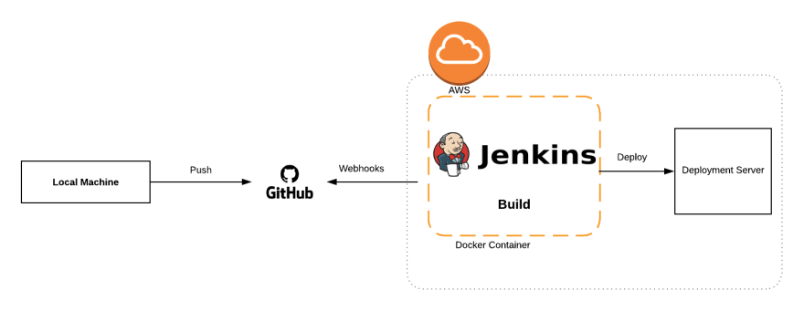

* Developer will run the “**Jenkin Job”** (Job used for deployment code from one environment into another environments). Once deployed is completed then developer will inform to tester throw mail and sent the unit testing documents attachments into JIRS tool (US/ Task present in JIRA).

1. To merger new code with existing application code / master branch into GitHub tool.

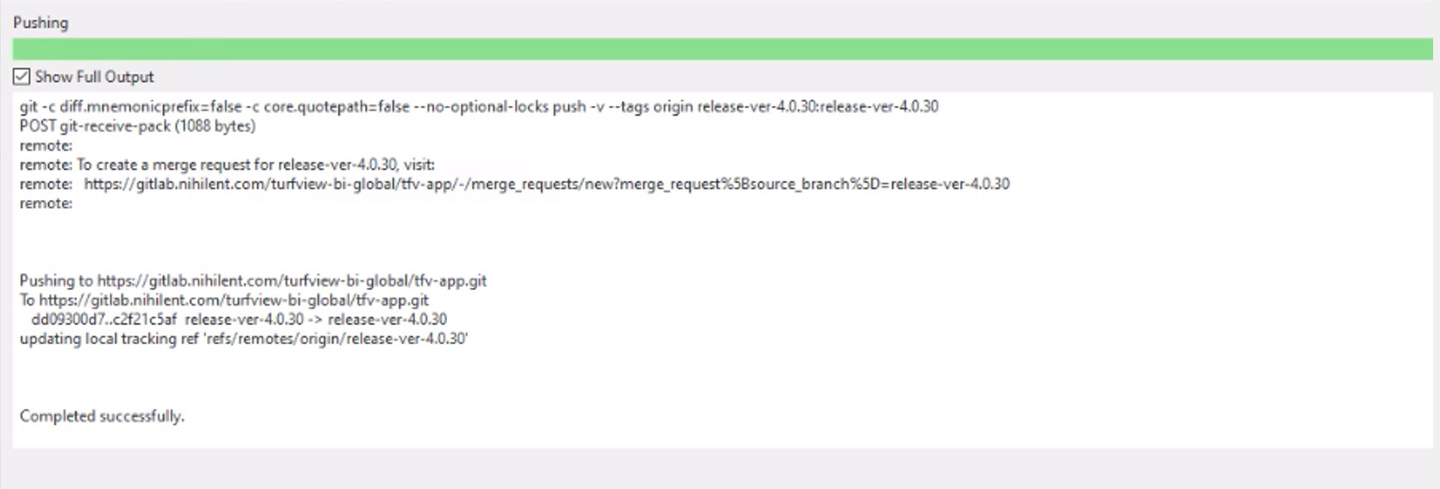

1. Deployed this code into SIT/ QA/ test environments, developer will run **Jenkins job**.

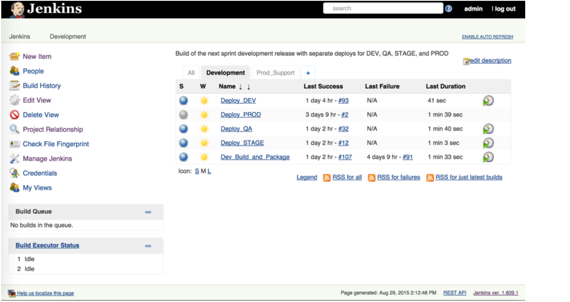

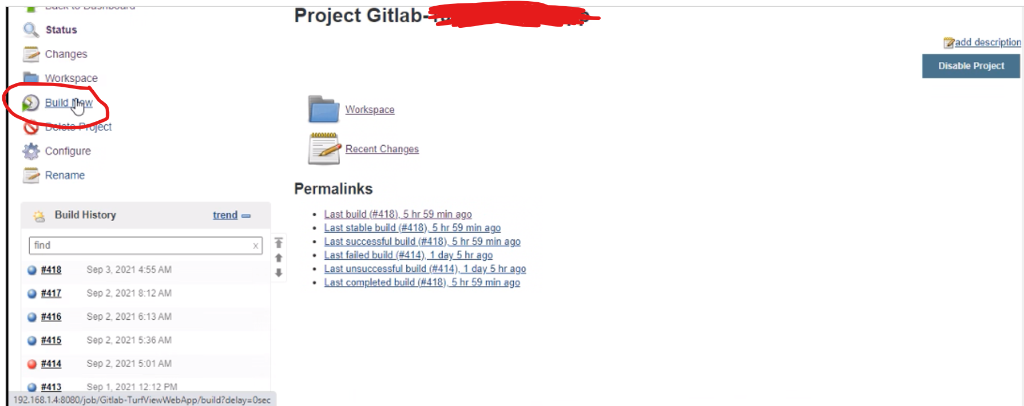

1. Once deployment done then developer will inform to tester throw mail and sent unit testing documents (throw JIRA tool). 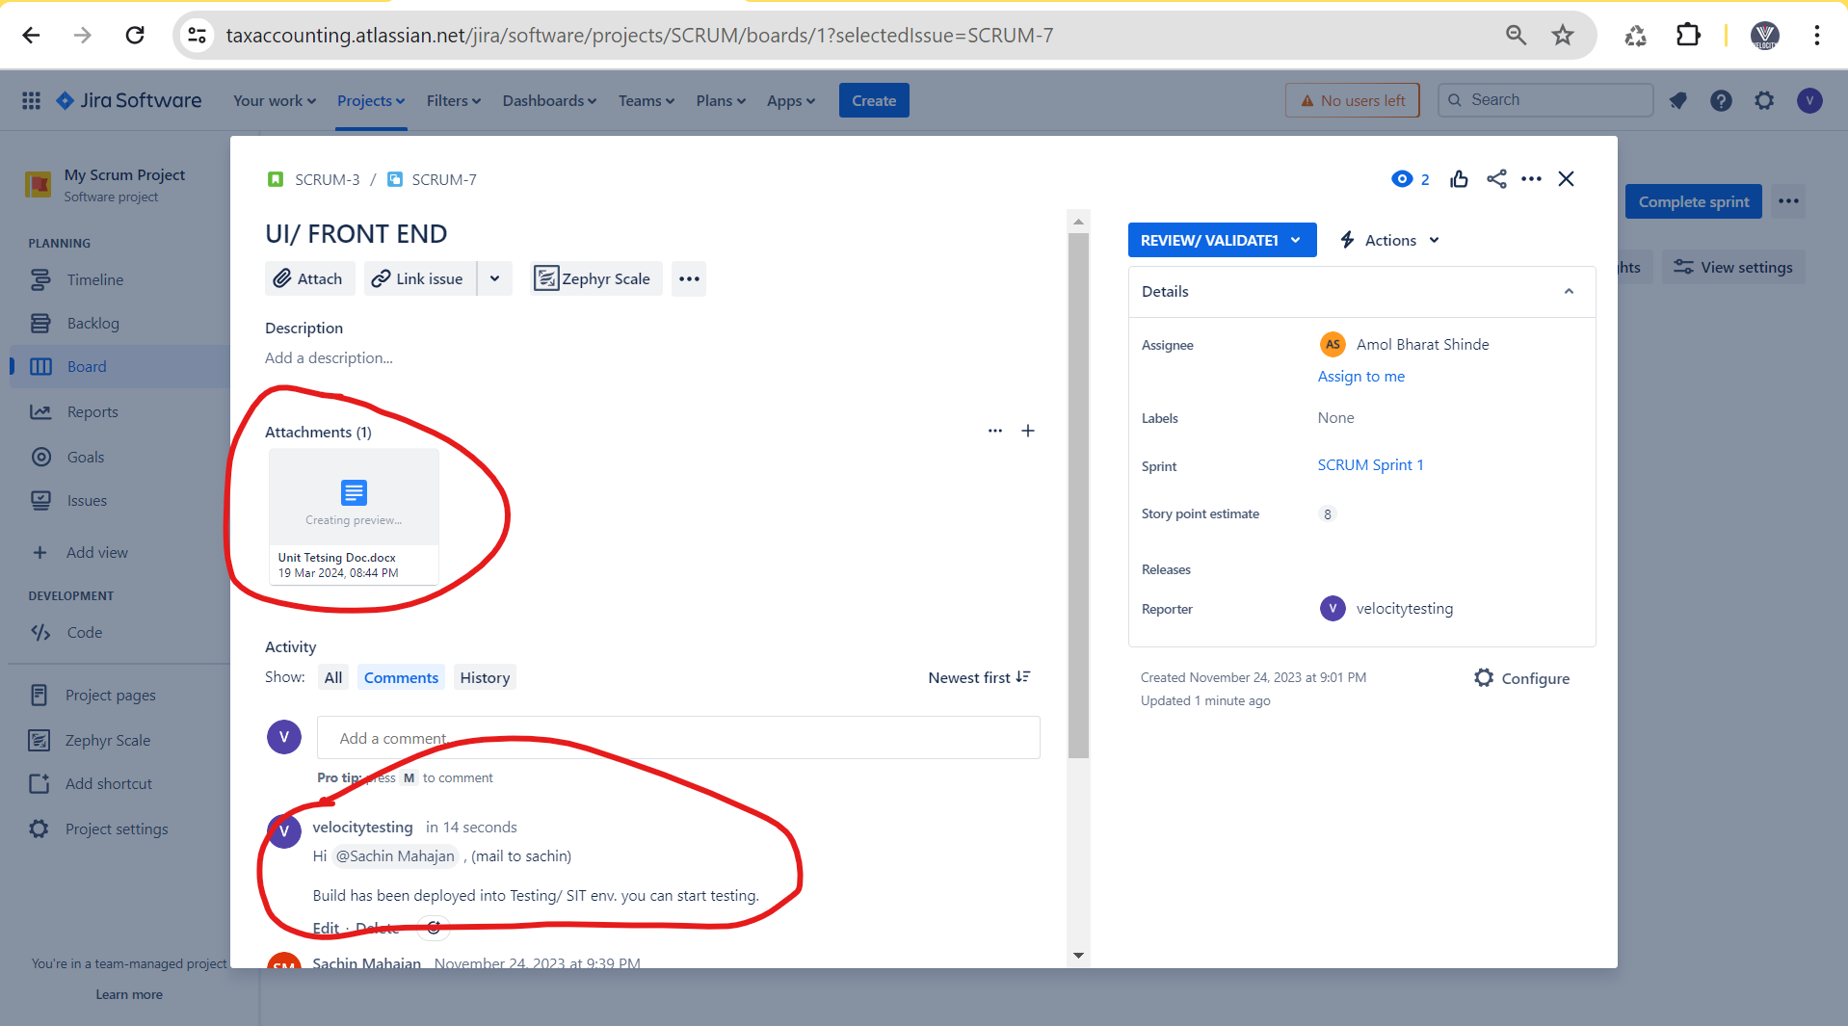
2. When tester need to open application in SIT / QA / test environments, then we will open application in **SIT / QA / test environments =** **192.20.60.141:8085/icic.com**

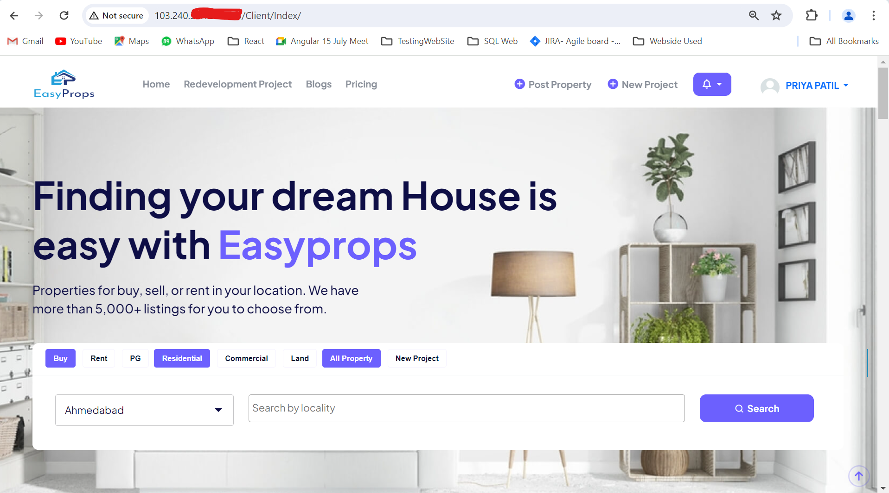

* In SIT environments, tester has different types of testing

1. **Sanity testing**
2. **Smoke testing**
3. **System & Functional testing**
4. **Retesting**
5. **Regression testing**

|  |  |  |  |
| --- | --- | --- | --- |
| **Testing** | **Check** | **Bug** | **Reports** |
| **Sanity Testing** | New Build – Stability check | Bug found – Build rejected | No test cases & no report |
| **Smoke testing** | New Build – Stability check | Bug found – Build rejected & find the root cause | No test cases & no report |
| **System & Functional testing** | Stable build – We will check functionality |  |  |

# Sanity testing**-

* When we got the “**New build”** from the developer then tester will do the **Sanity testing** in SIT/ QA /Test environments.
* Sanity testing is **first testing** in SIT/ QA /Test environments, sanity testing is also called as **Zero Level testing**/ **Build stability testing**/ tester acceptance testing.
* In sanity testing, tester will **check build stability** i.e. to check build is stable for testing or not?
* In sanity testing, tester will check

1. Check core **Core/ main functionality** of the build/ application.
2. Check **Link** present in the build/ application.
3. Check the **Tabs** present in the build/ application.
4. Check the **GUI/UI present** in the build/ application.
5. Check the **Navigation** present in the build/ application.

* For doing sanity testing, tester we will be required **1hr for doing sanity testing**.
* In sanity testing, tester will **not write any test cases** for doing sanity testing.
* In sanity testing, if tester **found a defect/ bug**, then tester will **reject the build** and inform to developer throw the mail (JIRA tool).
* Developer will fix the issue/ defect/ bug as soon as possible and deployed the new build against into SIT/ Test environments.
* When we got the new build from developed then tester will do sanity testing, in sanity testing tester will check the build stability.
* If tester will find that build is stable then we will do remains testing (system & functional testing).
* **Ex**. Developer has implanted the new build (V= 21.01) and sent this build for testing. Tester will do sanity testing (check stability of the new build). If build not stable then tester will **reject the build (V = 21.01).**
* Developer will fix this issue and prepare new build (V = 21.02) and sent this build for testing. Tester will do sanity testing (check stability of the new build).

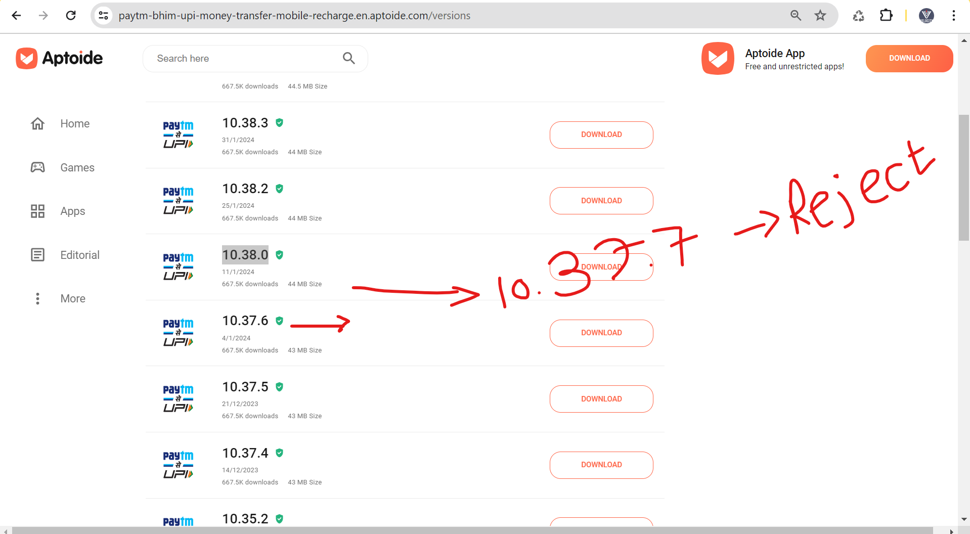

* In sanity testing, tester will find the issue/ bug/ defect due to **Core/ main functionality not working, Link/ tab not working, Run time problem, Environment issue /problem** (configuration file not change before the build into SIT/ Test environment), **Database connectivity** (data will not show in front end), **etc**

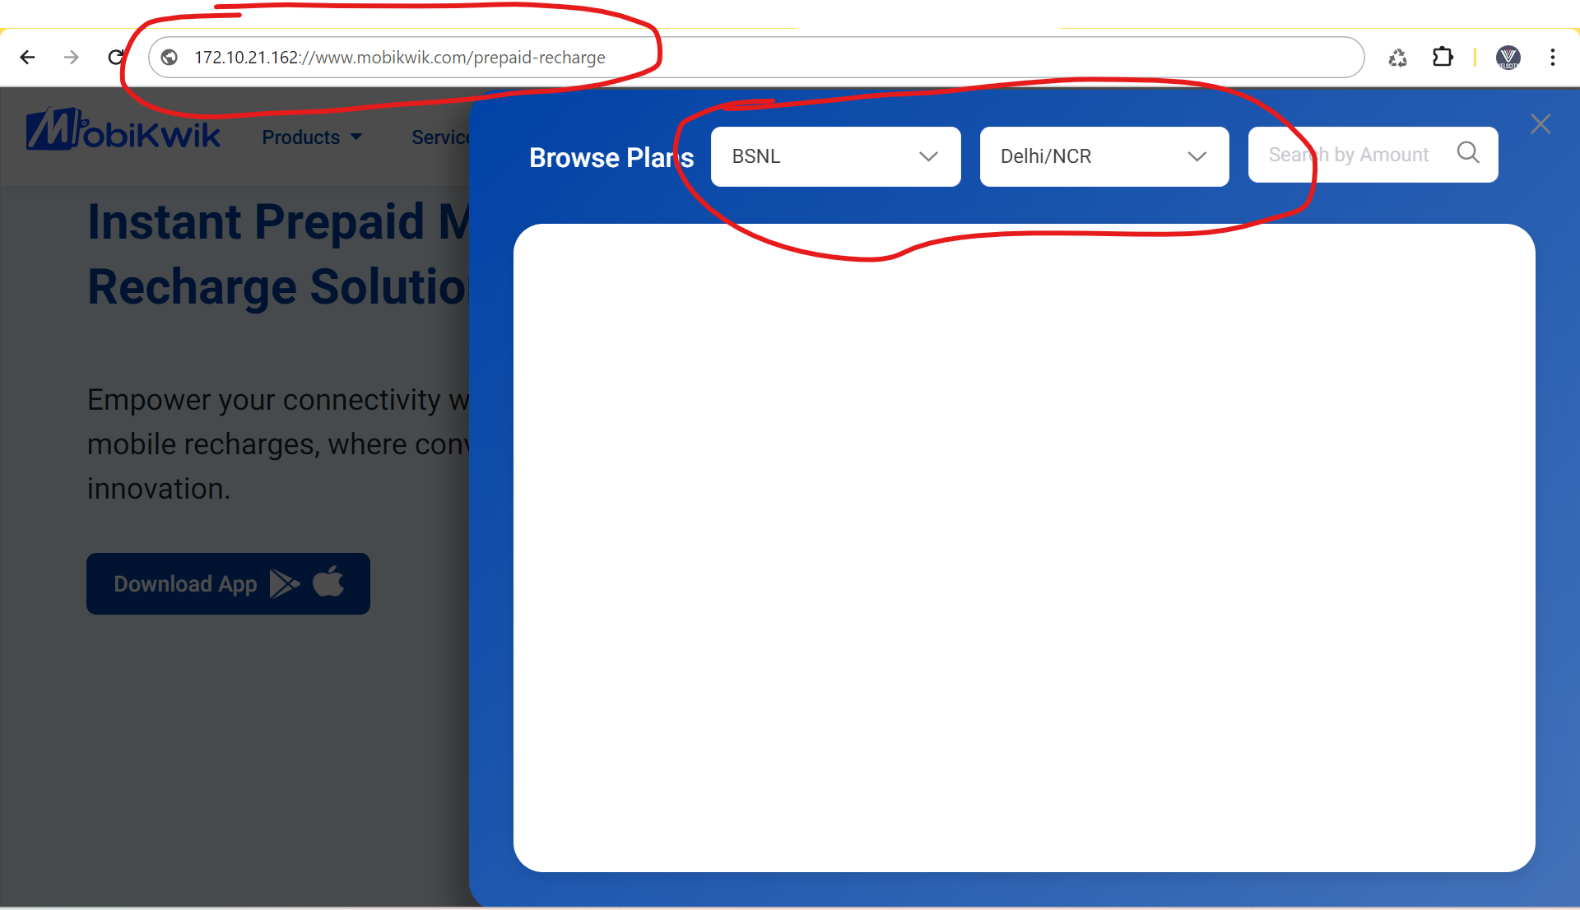

# Smoke testing**-

* Smoke testing it is extra sake of sanity testing.
* Smoke testing **advanced version** of sanity testing.
* When we got the “**New build”** from the developer then tester will do the **Smoke testing** in SIT/ QA /Test environments.
* In smoke testing, tester will **check build stability** i.e. to check either the build is stable for testing or not?
* In smoke testing, tester will check

1. Check core **Core/ main functionality** of the build/ application.
2. Check **Link** present in the build/ application.
3. Check the **Tabs** present in the build/ application.
4. Check the **GUI/UI present** in the build/ application.
5. Check the **Navigation** present in the build/ application

* For doing smoke testing, tester we will be required **1hr for doing smoke** **testing**.
* In smoke testing, tester will **not write any test cases** for doing smoke testing.
* In smoke testing, if tester **found a defect/ bug**, then tester will **reject the build** & **tester will find the root cause of the defect** (599rs roaming plan is not present) and inform to developer throw the mail (JIRA tool).
* **Smoke testing = Sanity testing + Troubleshooting/ root cause** – Tester
* **Smoke testing = Sanity testing + Package validation** (New Class of Roaming – 300 code line + Existing application) = 20, 000 code line – Developer
* Who to find the Troubleshooting/ root cause –

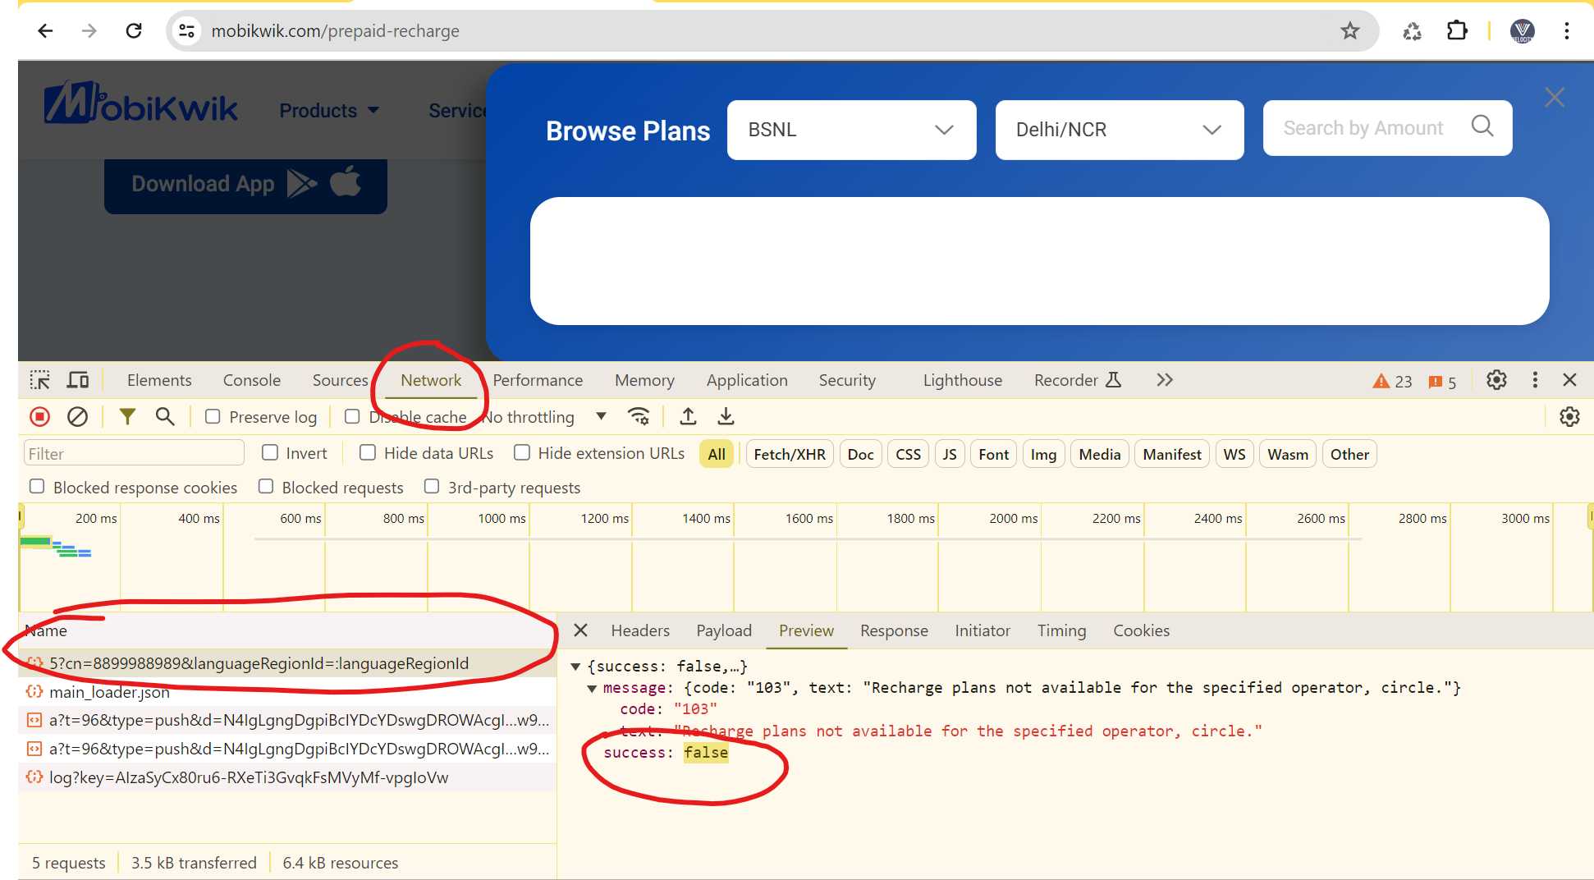

* In sanity testing, tester will find the issue/ bug/ defect due to **Core/ main functionality not working, Link/ tab not working, Run time problem, Environment issue /problem** (configuration file not change before the build into SIT/ Test environment), **Database connectivity** (data will not show in front end), **etc.**
* **In My project,** we are performing **Smoke testing** for build stability.

|  |  |
| --- | --- |
| **Sanity Testing** | **Smoke testing** |
| Sanity testing will do on the new build. | Smoke testing will do on the new build. |
| Tester will do the Sanity testing | Tester and developer will do smoke testing |
| In Sanity testing, we will check build stability i. e. to check either the build stable for testing or not? | In smoke testing, we will check build stability i. e. to check either the build stable for testing or not? |
| In Sanity testing, no test cases will be considered | In Smoke testing, no test cases will be considered |
| In sanity testing required 1hr for doing testing | In Smoke testing required 1hr for doing testing |
| If found defect, then we will reject the build. | If found defect in some testing, then we will reject the build & find the root cause of the defect. |
| Sanity testing it is subset of regression testing. | Smoke testing it is subset of acceptance testing. |
| In Sanity testing, we will check general heath check-up of the build. | In Smoke testing, we will check special heath check-up of the build. |
| In Sanity testing we will check proper deployment process of the build. | In Smoke testing we will check proper functionality present in a build. |

# System & Functional testing*-

* System & functional testing will be done of **stable build.**
* System & functional testing different testing will present,

1. **Usability testing**
2. **Functional testing 90 to 95%**
3. Performance testing
4. Security testing 0 to 5%

# Usability testing-

* In usability testing, tester will check **user friendly of the application/ build**.

1. **GUI (graphical user interface) / UI (user interface) –**

* In GUI/ UI usability testing, tester will check,
* Check look and feel of build,
* Check easy to use of build,
* Check speed of interface present in build.

1. **Manual support testing –**

* In manual support testing, Tester will check **sensitivities of input values** which will enter build.
* Ex. Facebook login – Mobile no. – Application mobile number enter.

**Task for Usability testing-**

* Go to Kotka bank application and open bank account and do usability testing on the page. -

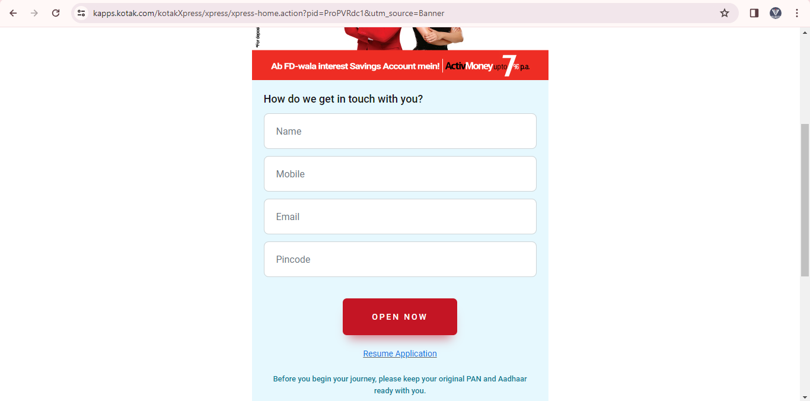

# Functional Testing –

* In functional Testing, Tester will check the internal & external feature of the application/ build.
* Functional Testing 2 types,

1. **Functionality testing (**internal feature)
2. **Non-Functionality testing (**external feature)

## Functionality testing (internal feature)-

* In Functionality testing, for check the internal feature, we will perform different coverage. (**BIEBSC**)

1. **Behavioural coverage testing**
2. **Input domain coverage testing**
3. **Error handling coverage testing**
4. **Backend coverage testing/ Database testing**
5. **Service level coverage testing**
6. **Calculation based coverage testing**
7. **Behavioural coverage testing-**

* In Behavioural coverage testing, tester will check **behaviour & property of the object/ web elements** (application elements – text box, check box, radio button, Button, Date picker, Pop, etc).
* Ex. Mobikiwik application – Rechange module –

|  |  |
| --- | --- |
| **Object/ web elements** | **Behaviour & property** |
| Text box | Accepted & Un- Accepted / Focus & un-focus |
| Radio button | On & off |
| Check box | Check & Uncheck / Tick & untick |
| Drop down | Select / Un- Select |
| Button | Enabled & Disabled |

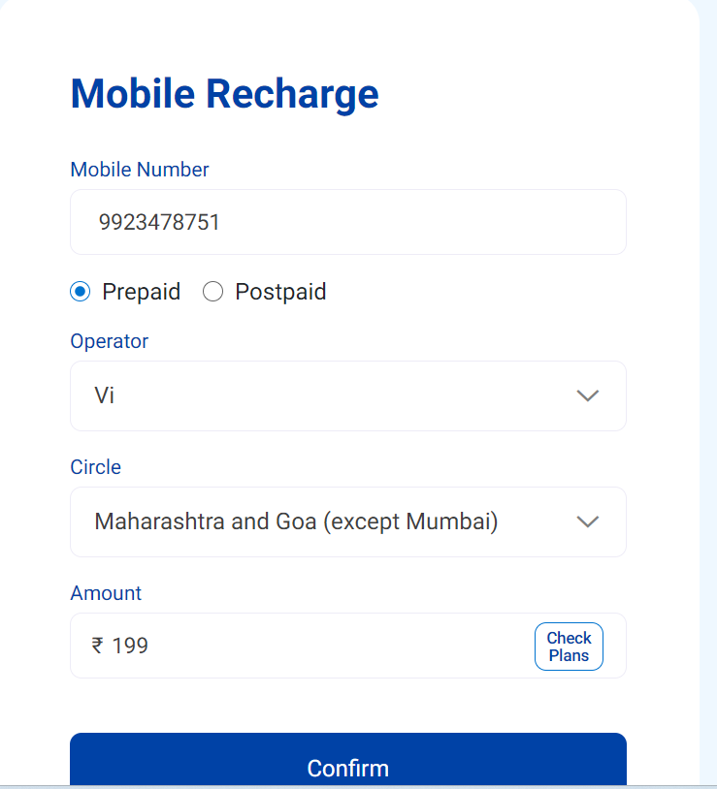

1. **Input domain coverage testing-**

* In Input domain coverage testing, Tester we will check the **input values data types & size/ length** by passing into the object/ web elements present in the build/ application.

1. **BVA (boundary values analysis) –**

* In BVA, Tester will check **input values size and length into the object/ web elements**.
* Ex. Mobiwik recharge module – Amount text box

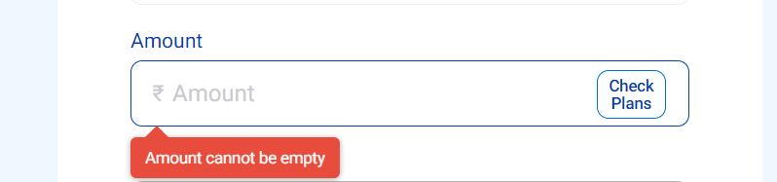

|  |  |  |
| --- | --- | --- |
| **BVA** | **Pass criteria** | **Fail criteria** |
| Amount text box | Max = 9 input values / digit | Max + 1 = 10 digits |
| Min = 1 input values / digit | Min -1 = 0 digits |

* Ex. Facebook -Password

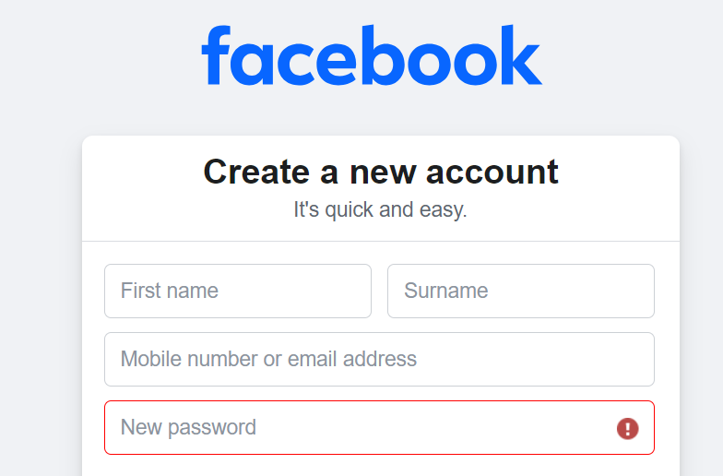

|  |  |  |
| --- | --- | --- |
| **BVA** | **Pass criteria** | **Fail criteria** |
| Password text box | Max = 8 to 10 input values / digit | Max + 1 = 11 digits |
| Min = 6 input values / digit | Min -1 = 5 digits |

1. **ECP (Equivalent class partition) –**

* In ECP, Tester will check **input values data types into the passed object/ web elements**.
* Ex. Mobiwik recharge module – Amount text box



|  |  |  |
| --- | --- | --- |
| **ECP** | **Pass criteria** | **Fail criteria** |
| Amount text box | Integer values | Decimal values (10.50) |
|  | Charter values |
|  | Binary values (1/ 0) |

* Ex. Facbook -Password

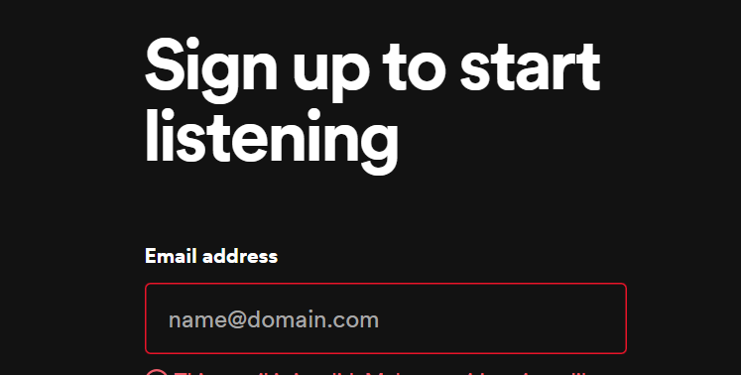

|  |  |  |
| --- | --- | --- |
| **ECP (data types)** | **Pass criteria** | **Fail criteria** |
| Email address text box | Only Charter values | Only Integer values |
|  | Only Decimal values |
|  | Only Special charter (@, %, $) |

1. **Decision table testing techniques –**

* In Decision table testing techniques, Tester will **check input values combination which will be accepted/ shows the result** into web elements/ object.
* Ex. Icic login page -

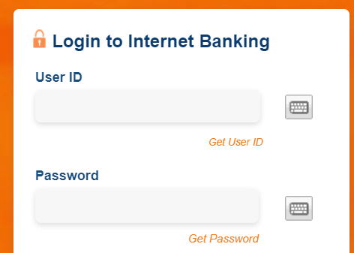

|  |  |  |  |  |
| --- | --- | --- | --- | --- |
| **Object** | **Combination 1** | **Combination 2** | **Combination 3** | **Combination 4** |
| **User ID** | Valid | In-Valid | Valid | Valid |
| **Password** | Valid | Valid | In-Valid | Valid |
| **Submit** | Click | Click | Click | Not Click |
| **Result** | Home page display – Pass criteria | Login page shows - Pass criteria | Login page shows – Pass criteria | Login page shows – Pass criteria |

1. **Error handling coverage testing-**

* In Error handling coverage testing, Tester will check **different error present by passing in-valid data into the web elements/ object.**
* **Ex.** By passing in-valid data (6-digit pass into mobile no. text box)

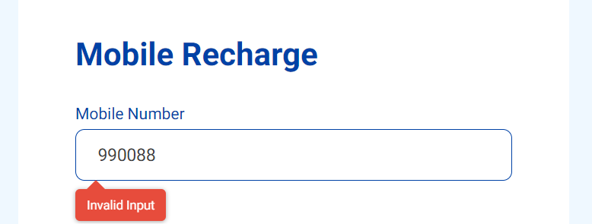

* **Ex**. By passing null/ blank data (null/ blank pass into mobile no. text box)

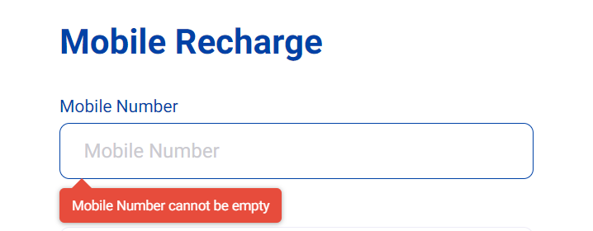

* Which error will be present for the object/ web elements, that **error will be present in SRS documents / US.**
* If we found error not present object/ web elements for in-valid then we will raise the bug/ defect. (JIRA/ Azure DeVos tool)

1. **Backend coverage testing/ Database testing-**

* In Backend coverage testing/ Database testing, Tester will check data which is Stord the backend / database, when we have performed any operation from the front end.
* **Ex.** Flipkard – Mobile item online buy – Date = 25/03/24, Date – 20.45pm, Amount – 29,999rs, Mobile company – iPhone, offer – 10% discount, Payment card – ICIC bank – For this order all data will be stored in the backend / database.
* **Tabel name** we will get form the **unit testing documents** from the developer.
* For check backend / database testing, tester will run **SQL quires** in SQL tool.
* Ex. **SELECT * FROM table_name (Table name - cust.cust_order_details)**

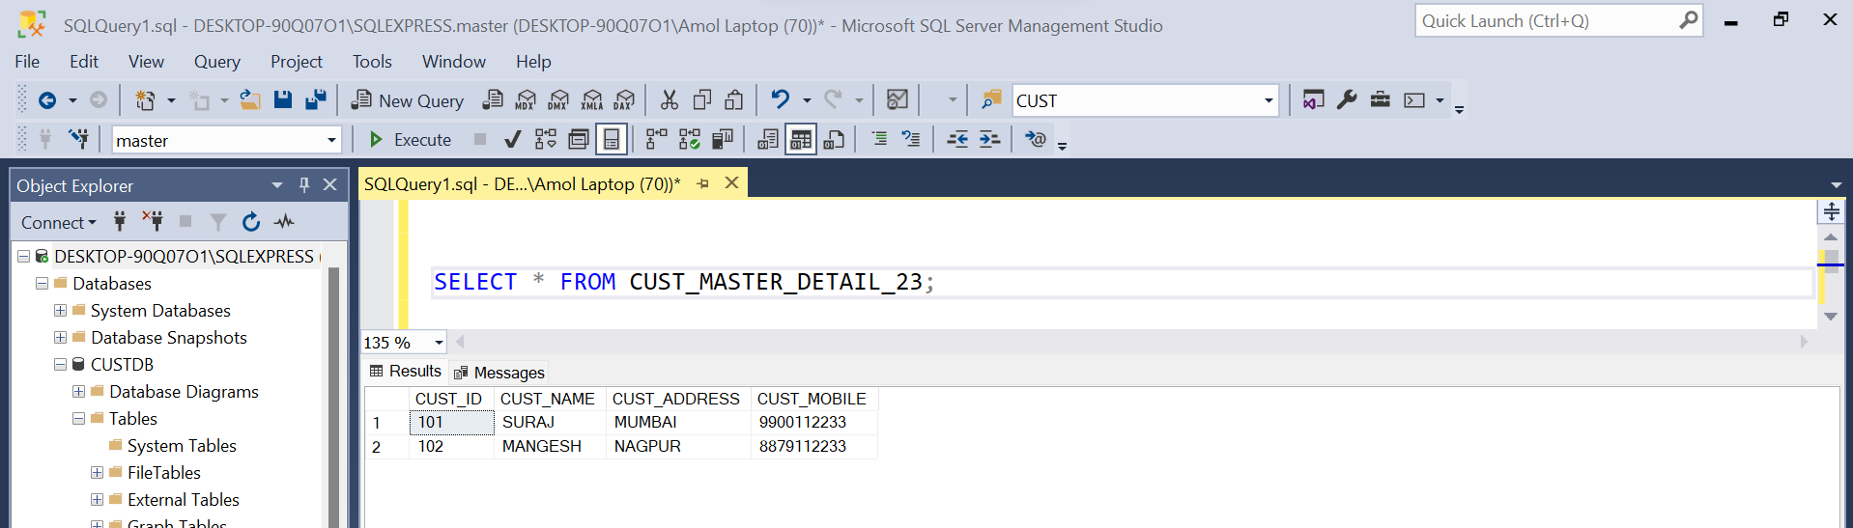

1. **Service level coverage testing –**

* In Service level coverage testing, Tester we will **cheek sequential service** will present or not in application/ build.
* **Ex**. Paytm – Recharge mobile – Mobile No. 🡪 Operator selection 🡪 Circle selection 🡪 Fast recharge/ Quick recharge = Untick 🡪Promocode page (service) 🡪 Plane select = 299rs 🡪 Payment page 🡪 Successfully recharge done.
* **Ex**. Paytm – Recharge mobile – Mobile No. 🡪 Operator selection 🡪 Circle selection 🡪 Fast recharge/ Quick recharge = Tick 🡪~~Promocode page – Not shows~~ (service) 🡪 Plane select = 299rs 🡪 Payment page 🡪 Successfully recharge done.
* **Ex**. Swiggy order place –

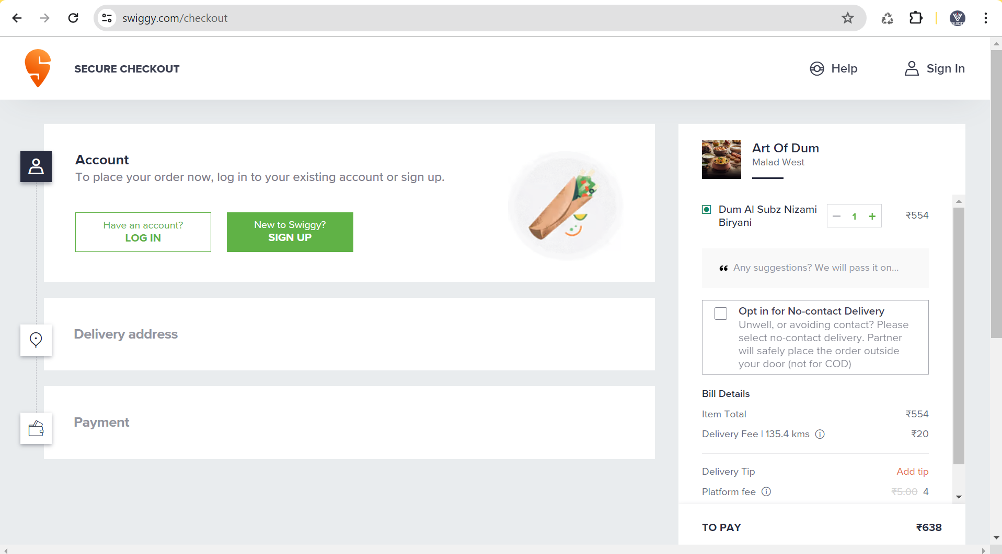

1. Without login order place – Login service + Delivery address + Payment service
2. With login order place – ~~Login service~~ + Delivery address + Payment service
3. **Calculation based coverage testing-**

* In Calculation based coverage testing, Tester will check **arithmetical calculation present in the build/ functionality.**
* **Ex**. Swiggy order – Pizza = 699rs 🡪 Delivery address 🡪 Promo code = No apply 🡪 Payment = 699rs.
* **Ex**. Swiggy order – Pizza = 699rs 🡪 Delivery address 🡪 Promo code = 20% off on current price 🡪 Payment tab = 699rs – 20% of 699 = 699rs – 138rs = **561rs.** (invoice will shows all payment calculation).

## Non-Functionality testing (external feature) –

* In non-functionality testing, tester will check the external feature.
* To check external feature, we will perform different coverage. (RCCIISPG)

1. **Recover coverage Testing**
2. **Compatibility coverage Testing**
3. **Configuration coverage Testing**
4. **Intersystem coverage Testing**
5. **Installation coverage Testing**
6. **Sanitation coverage Testing**
7. **Parallelization coverage Testing**
8. **Glocalization coverage Testing**
9. **Recover coverage Testing -**

* In Recover coverage Testing, tester will check **either application/ build is recovering from unnormal situation.**
* **Ex.** Swiggy application – Item Pizza panner 🡪 Delivery address 🡪 Payment tab = UIP - Phone pay 🡪 Swiggy application = Timer = 5min (loader running). (**Phone pay – Notification open =** Open payment enter but wrong UPI password / Payment decline/ payment takes 10 min / Internet problem.)

1. If unnormal not handled = Swiggy application still time shows after 5 min.
2. If unnormal handled = Swiggy application – time out message.

* **Ex.** Flipkart – order place – Payment tab – debit card enter – Card details – payment process – close or cancel button click or page refresh (unnormal situation) - Payment tab will open

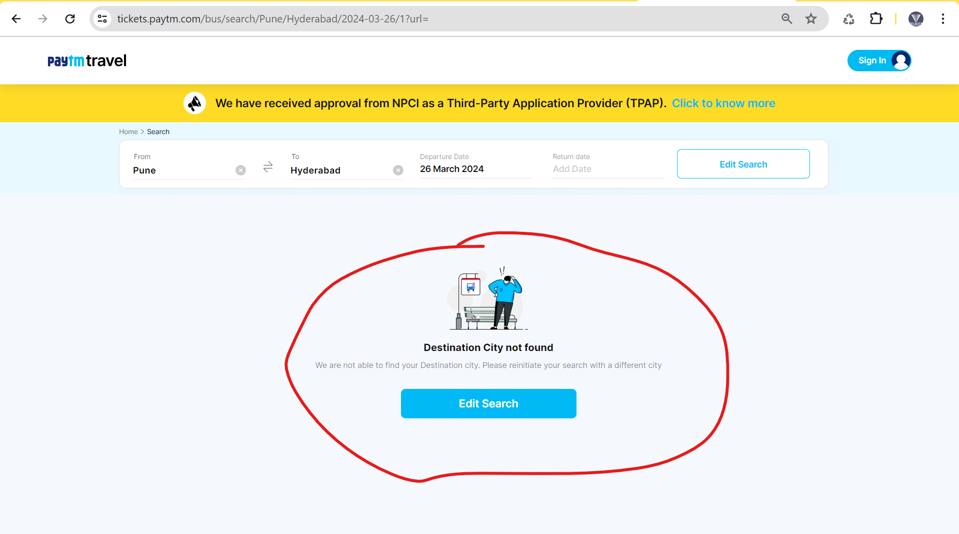

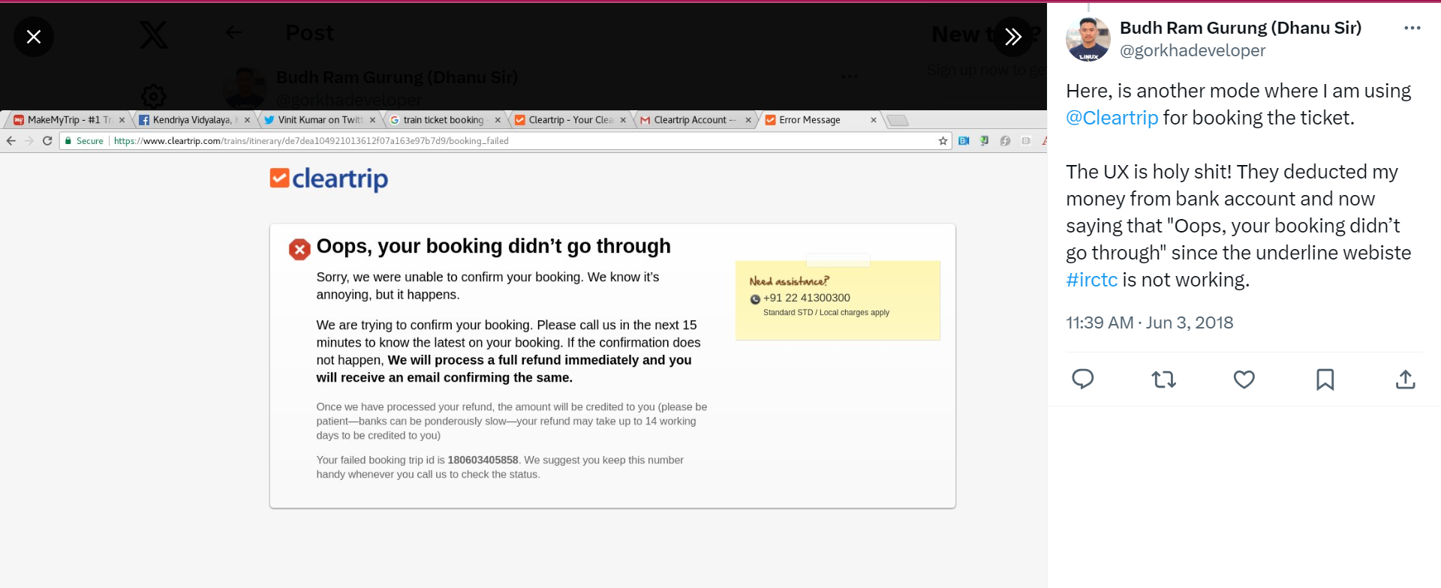

1. **Compatibility coverage Testing/ Browser Compatibility coverage Testing -**

* In Compatibility coverage Testing,Tester will check either the build is compatibility/ comfort with OS (browser).
* I have worked in **Browser Compatibility coverage Testing**, 2 type of testing

1. **Cross Browser Compatibility Coverage Testing-**

* Tester will run the same build/ application on **different browser**. **Ex**. Paytm application open in Chrome (90% used for testing), Firefox, Edge, Safari, Opera Mini, etc

1. **Version Control Browser Compatibility Coverage Testing –**

* Tester will run/work the build/ application on **same browser with different version will be different**. **Ex**. Paytm application open in Chrome browser (Version 123.0.6312.86, Version 122.0.0000.00, Version 120.0.0000.00, Version 110.0.0000.00, Version 100.0.0000.00, Version 93.0.0000.00, Version 85.0.0000.00, Version 80.0.0000.00, Version 71.0.0000.00)

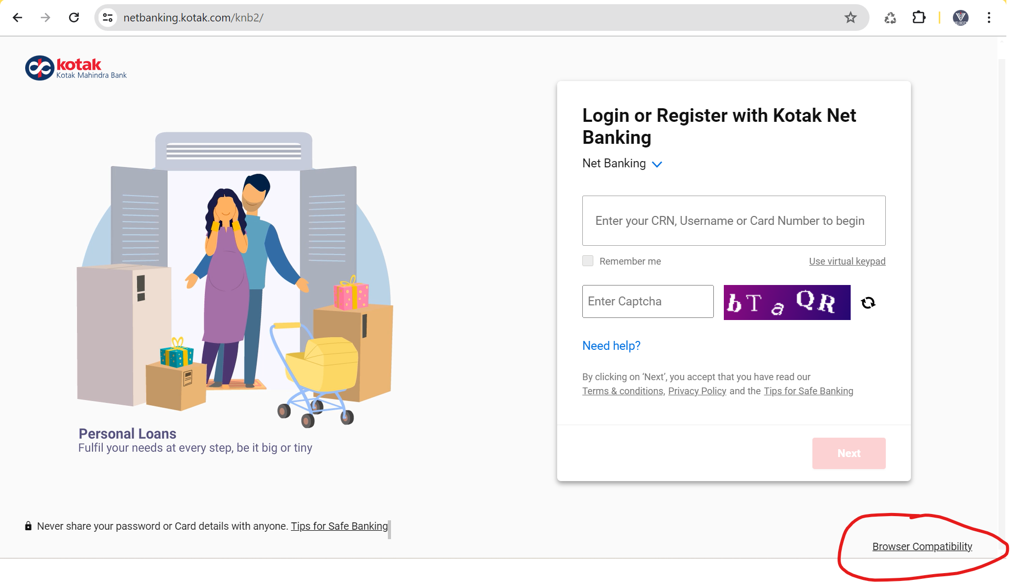

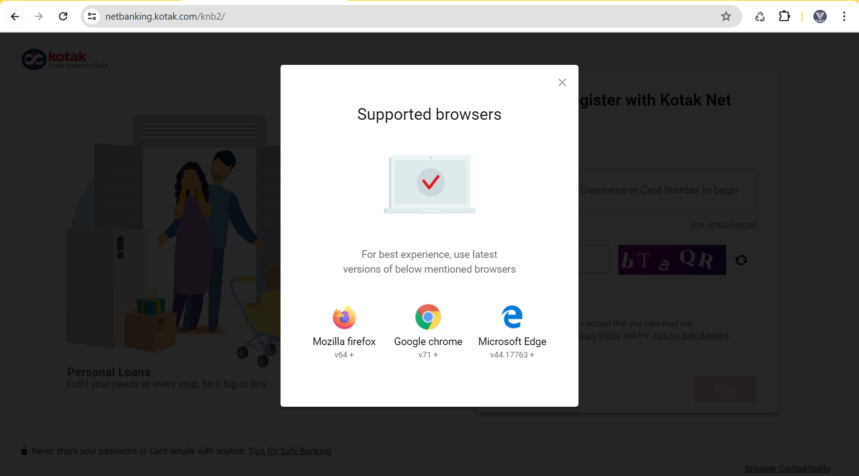

* To run different version of same browser in a laptop, we will **use remote desktop**.

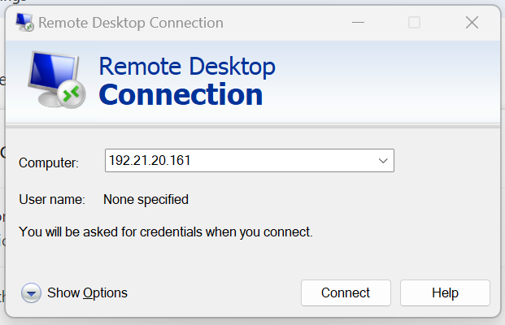

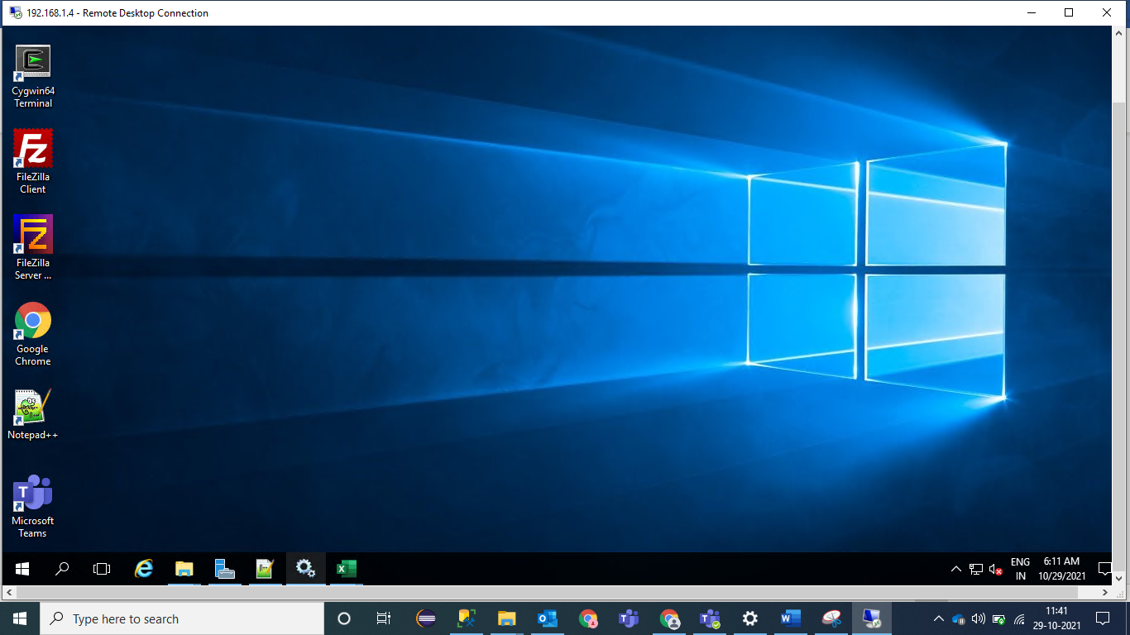

1. **Configuration coverage Testing/ Hardware coverage Testing -**

* In Configuration coverage Testing also called as **Hardware coverage Testing.**
* In Configuration coverage Testing, Tester will check build is supporting to hardware device.
* **Ex**. Google – Search box – Audio button add –

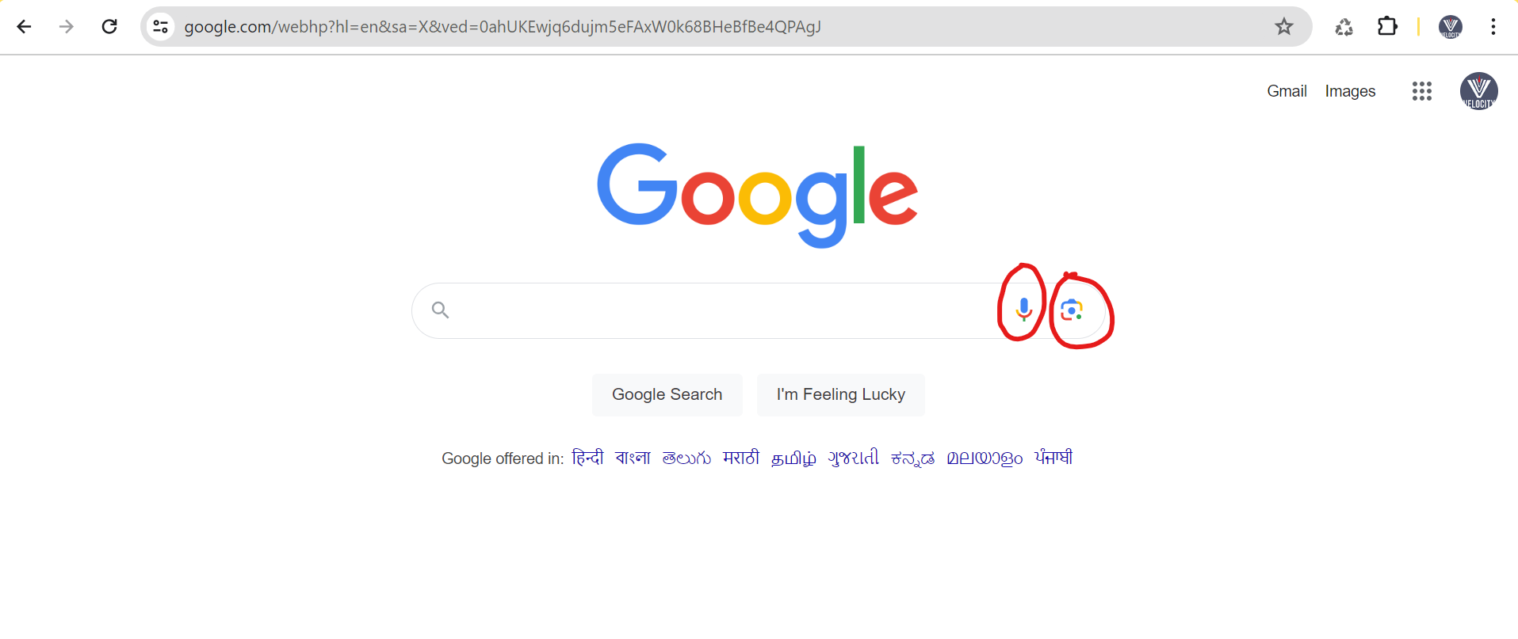

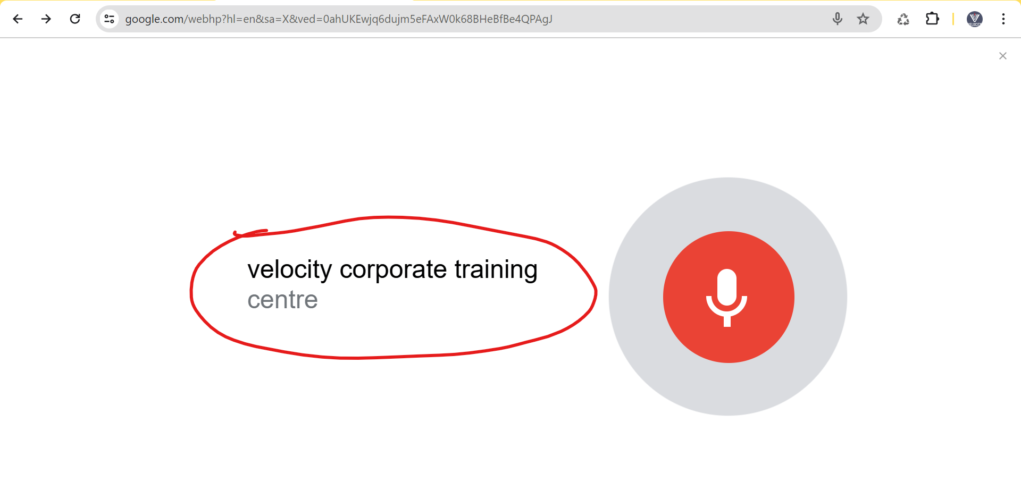

* **Ex**. Filkard – Mobile item – order place – payment tab – Oder details tab and invoice download – Invoice download button – PDF open order details – Printer icon click.
* **Ex**. – Google meeting – Audio driver will shows.

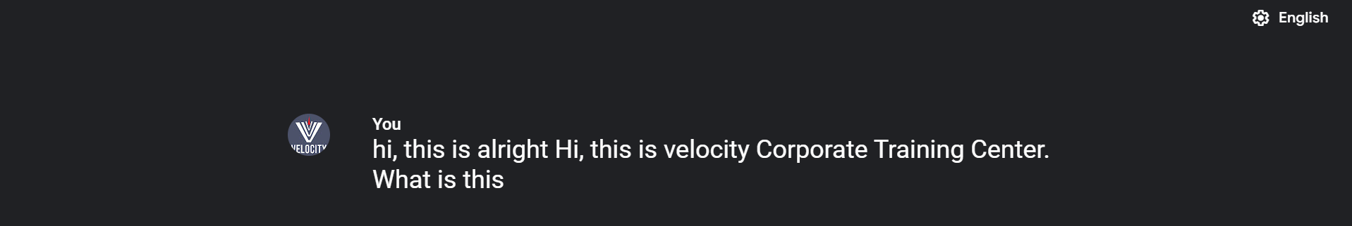

1. **Intersystem coverage Testing –**

* In Intersystem coverage Testing, Tester will check how the how the application/ build will take **interchange the data** from other application.
* **Ex**. Phone pay – mobile number money transfer – amount enter – UPI password – shows message as – Your Bank is not responding (400- bad request, 500- internal server error) (Bank system is not working / bank not reposing).

IRCTC – Train servicer

Paytm – Train booking

1. **~~Installation coverage Testing~~ – Not performed**

* In installation coverage Testing, build need to run on client server (USA)

1. **Sanitization coverage Testing –**

* In Sanitization coverage Testing,Tester will **check extra/ addition feature which is present the application**/ **build**, but this feature not mentioned din US/ requirement.
* **Ex.** Login page – Login should do with mobile number only.

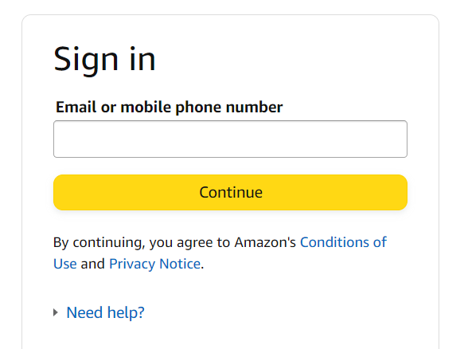

* If some extra/ addition feature which is present the application/ build, Tetser will raise the bug.

1. **~~Parallelization coverage Testing~~ - Not performed**

* In Parallelization coverage Testing, Tester will check similar feature present in your build and other application which is present in client location.

1. **Glocalization coverage Testing –**

* In Glocalization coverage Testing, Tester will check build / application either it is supporting to all languages.

1. **Stander languages support –** Check English languages will support to the build.
2. **Reginal languages support -** Check reginal (Hindi, Tamil, Marathi, Kanada, etc) languages will support to the build.

* **Ex.** Tamil languages new development – current US work – Tester need to test – google transiter to check all text in Tamil.

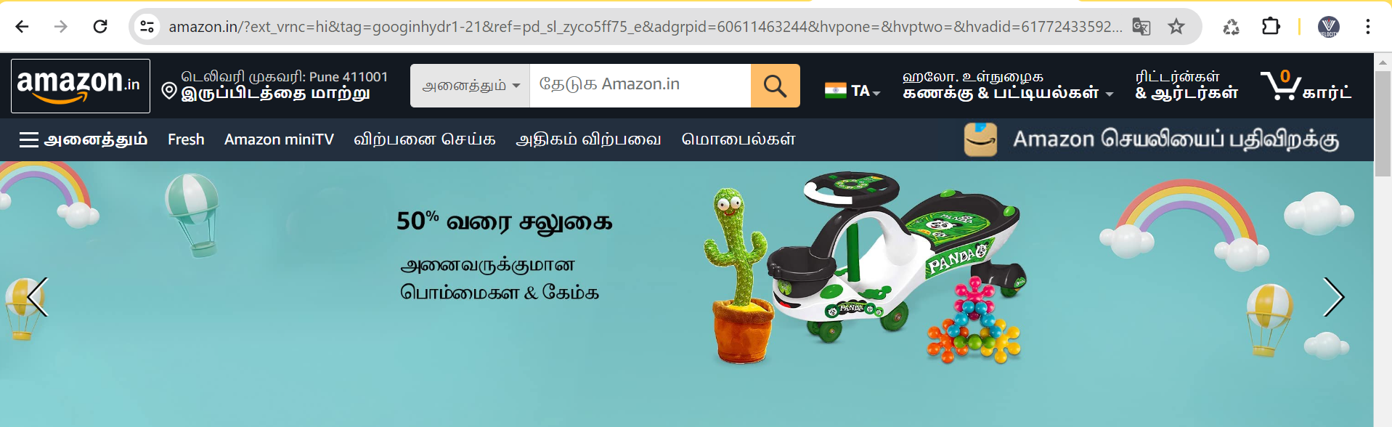

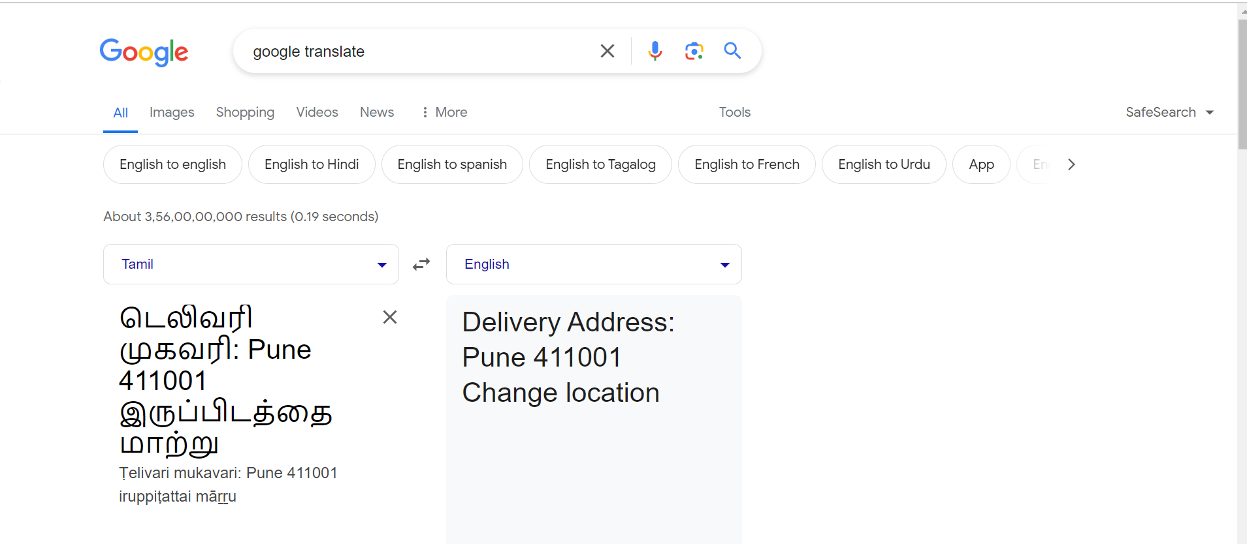

* **Beta Version –** This version of the build is provided or supported to limited customer / region.
* **Ex.** In goggle meeting, Janpness languages support will shows for India only not provide to other Europe country.

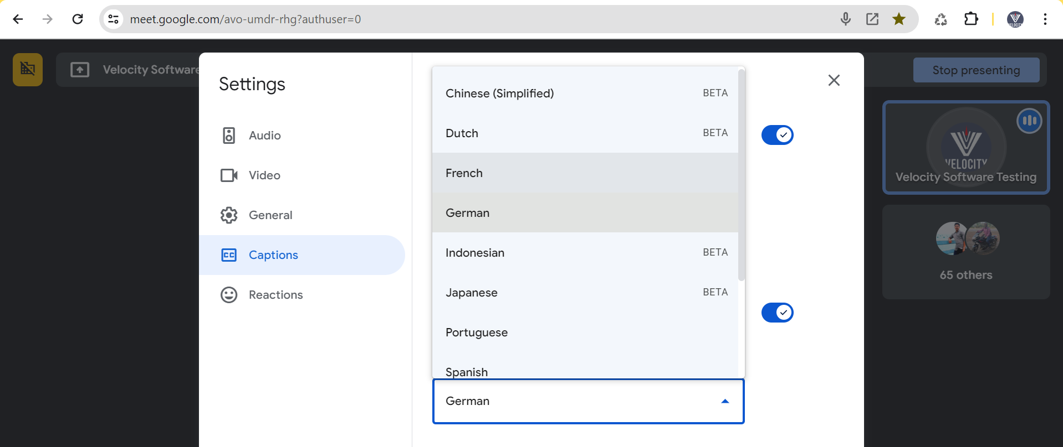

# Task to student –

**Task 1** - To check all converges for amount text box present in gpay/ phonepay.

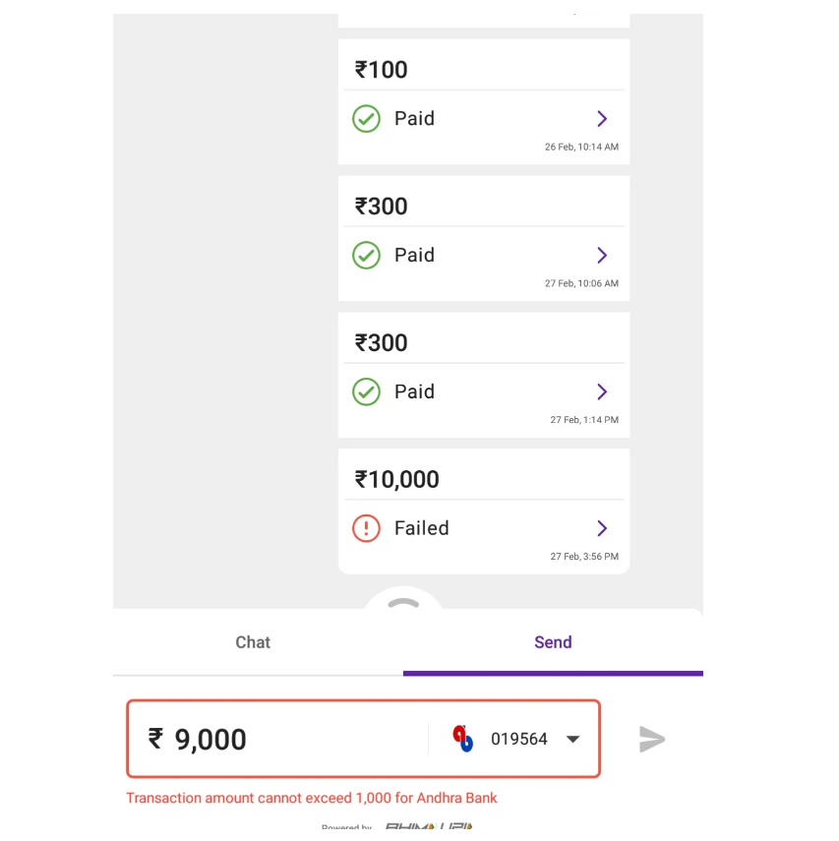

EMI calculator – https://emicalculator.net/

**Task 2** - To check all converges in EMI calculator text box and all field present.

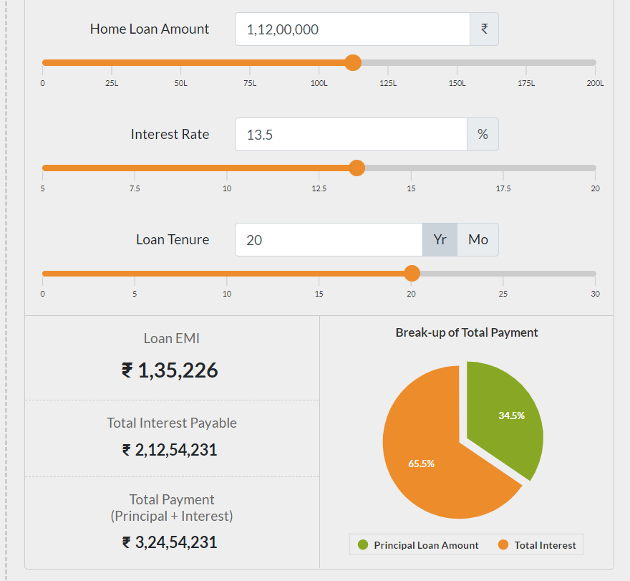

# IT Related knowledge –

* Resign / paper dala – **Notice period – 1 month/ 2 month / month**
* Project XYZ– Sumit Tester work– 2 exp/ 3 exp – Resign current project.

1. New tester opening – job searcher - Project XYZ allocation.
2. Company existing tester/ Bench period (no project allocation) – Project XYZ allocation.

* KT for Project XYZ – Sumit (Resign current project) will give KT to new tester (New hiring/ Company existing tester).
* Initially, for new tester (Me) small work will be allocated and if we have doubt or small problem then we will ask to person who has resigned or to the buddy (who give the guide to you).
* If you are working new in project then in 1 month you have allocated only on 1 US or 2 US on a sprint becz you are new in project and project knowledge.

# Interview Question –

1. Why there is a bug in software/ application?

* **Answer –**

1. **Which tool / farmwork used for unit testing?**

* **Answer-**